Yuan Training 2025-07-11
July 12, 2025
6:46 PM

RJLU Remediation & Repapering Process – Notes Summary

1. Purpose of Repapering
- Repapering means implementing a whole new set of documents and procedures for clients.
- It is part of a remediation resolution process to ensure client documentation is up-to-date and compliant.
- Compliance assists Supervision and participates in heightened supervision cases.
- DC issues (District Compliance) often trigger remediation and repapering processes.

2. RJLU Compliance Responsibilities
- Key deliverables:
  - Track documentation
  - Ensure proper sign-offs
  - Maintain procedural integrity throughout repapering

3. Procedure for Repapering
Procedure for repapering: RJLU(R)-(1-Compliance)-(1.audits,exams, change activities, investigations)-(investigations)-(dc investigations)-(account remediation)-(documents, tracking, sign off)
Step A to E (in folder)
- Two templates are used to complete the remediation documentation.
- RJLU compliance responsibility pertaining to DC Issue
Downloading Old Files (NetX360)
- Search account in NetX360
- Go to Document Center → Imaged Documents
- Scroll to the bottom to locate older documents
- Download the document
- Extract information (e.g., driver's license) and save in the appropriate folder
⚠ If account says "complete" but no document is found, it's possible the new document hasn’t been uploaded yet.

4. Ambassador Agreements & RTQ
- For Ambassador Non-Discretionary Clients:
  - If a client has 5 accounts, only 1 RTQ is needed.
- Ensure:
  - New account form is signed
  - Ambassador agreement is present

5. Document Review & Remediation Template
- Enter account in NetX360, check the P74 folder for relevant documents
- Find Adoption Agreement and client profile
- Create and store a file as:
Name - Account Name - Account Number
- Open both old and new documents side-by-side
- Use the Document Remediation Template:
  - Copy key info: client profile, IRA details, account number
  - Note differences clearly (max 1 line per cell, no text beyond column H)
  - Use "Insert → Create from file" to insert documents:
    - First the old, then the new
  - Do not create PDF files

6. Notes on Validity Checks
- E-signature is valid unless flagged
- If IP address differs, note it
- Sample notes for differences (Step 4):
  - Legal address changed from A to B
  - Government ID type changed (e.g., from DL to Passport)
  - ID expired on 04/24/2025
  - Investment experience years remain unchanged
  - Employment years remain unchanged
  - Sweep option product changed from RFI to RX

7. Clearinghouse & FINRA Monitoring
- Use FINRA Weekly Update Relay as a primary source for compliance updates
- Regularly monitor for:
  - Rule changes (e.g., FINRA Rule 3240 amendments)
  - Regulatory guidance relevant to RJLU
- Select and summarize a few important/interesting topics
- Share insights and updates with Ash

Yuan Training 2025-07-14
July 15, 2025
3:13 PM

Compliance RJLU Inbox Management
- Review the inbox every 15 minutes
- For new emails:
  - Read, categorize, and flag those relevant for today
  - When finished, mark as complete
  - Forward email if appropriate (e.g., not a RJLU account)
- RJLU account prefixes:
  - Valid: 1RJ or P34
  - If account starts with P35 or is not RJLU, forward to Compliance Help for RJL handling
- Important messages:
  - Create rules for sorting or flagging them
  - Rules can be based on sender or content tags (e.g., "Sent to…")

Account & Broker Identification
- BNY Mellon–Pershing: Carrying broker
- AJR: Refers to Raymond James
- IP: Advisor Code

Compliance Oversight Tasks
- Navigate to Z Operations
- Step 1: Conduct Restricted Securities Review
- Use NetXreports to generate a holding snapshot

Research & Data Entry, Example: Alaska Energy
- Use Factset:
  - Search by company name for data analysis
- Use 360 Accounts:
  - Go to Document Center
  - Check for:
    - Mandatory items
    - Inquiry status
    - Payment updates
- For issuer identification:
  - Refer to transfer agent

Syndication

Introducing Broker (IB):
- Acts as the client-facing firm
- Brings in new clients and manages relationships
- Does not hold client assets or execute trades directly
- Sends trade orders to a carrying broker for processing
- Focuses on sales, support, and advisory services
- Earns fees or commissions for referring business
Carrying Broker (CB):
- Handles the back-office operations
- Executes, clears, and settles trades
- Maintains custody of client funds and securities
- Prepares client statements and confirmations
- Manages margin accounts and regulatory reporting
- Charges fees to the introducing broker for these services

Yuan Training 2025-07-15
July 15, 2025
10:19 AM

DC Remediation
"Step" mentioned below refer to the Steps in the Amended Version
No issues observed
Wet Signature in the Previous Version, Digital signature in the Amended Version

  - NYSE Hours
    - Regular business days: Monday–Friday
    - Operating hours: 9:30 a.m. to 4:00 p.m. Eastern Time (ET)
  - Trade Reviews & Data Issues
    - Data team did not receive Tuesday’s data
    - Template and reviews processed manually
  - Dataphile Navigation
    - Systems: Prophile OpenView → RJLU → PROtrade
    - Action: Click “Enter Last Business Date”
    - View: Trade and non-trade activity history
  - Compliance Oversight
    - Check FINRA blotter
    - Z-Operations for compliance review
    - Emails show allocation; no further action required
    - Trading restriction output: coordinate with Operations team

  - Blue Sky Sheet
    - Blue-skied: Yes
    - Notes: FDIC-insured CD present, no issues found
  - Canari Website Check
    - Company verification conducted
    - One company marked as “Exempt”
  - Pro Client Sheet
    - Comment: trade is in opposite directions, no issues

Connect to operations team, trading restriction output

Yuan Training 2025-07-16
July 16, 2025
9:26 AM

Full prohibited, canadian dollar check, categorize to Roman, flag it today

Process date last day
More options

RSTK, DELIVERED FROM ACCOUNTS…ONE BY ONE
GO TO DAILY READE REPORTS 2025
Daily trade dashboard reports

Pro-client
Compering CUSIP, if not same remove it

Hondo Private Equity
1-compliance-flip symbol to CAD
netx 360-servicing
Accounts: positions
Par to gloss
Pershing OpesCenter
COR correspondence
Go back to account, and add note

Accounts-positions
General inquiry
Subject: re-legend shares certification
According to previous lengend removal documents, it is required that the shares are relegended after 90 days of the legend removal.

BM Change

User IDs and entitlement

Yuan Training 2025-07-17
July 17, 2025
11:36 AM

Low price security questionnaire
Due diligence process

Branch-review-aa branch review checklist and tracking

DC REPAPERING PROGRESS:
Answers needed from fa 2 accounts
Ready for bm review 7 accounts
Incomplete docs 5 accounts
Pending correctio from fa 1 account
Under dispute 3 accounts

Yuan Train 2025-07-18
July 18, 2025
11:31 AM

Dashboard
Process date: last business date
All should be 8 files
The 8th file has no processing date, just download it
Export to excel file
Copy and paste
Save to:
R:\Compliance Oversight\Daily Trades Reports\Daily Trade Reports 2025\Daily_Trades_Dashboard_Reports\IndvFiles

Add personal drive folder

Factset:
Contrl c+control v from excel
Stocks bonds funds
e.g. Apple dividends-company/security-corporate actions
Snapshot
GeoRev
Return Analysis
Company/Security
Markets: to indices performance
Today's Top News

Pershing request
Security description: start with RSTK, then deposited as RSTK
Pace block: Servicing-ops center-pace-flag account-then search account number(1RJ)
Flag an Account
1. Go to: Menu > Service & Operations > OpsCenter. The Online Applications menu displays.
2. Select the hyperlink for PACE - Pershing Automatic Cash Exchange. The PACE Main Menu displays.
3. In the Function field, select FLAG-Account Flags.
IF IT'S REMOVED, Select AFLAG
4. In the Account field, enter an account or office number.
5. Click Display. Flagged account information displays.
6. Click Add.
7. Enter the account number in the From Account box.

Hi Wes,

The PACE block has been temporarily removed to allow the ACH transfer on March 17, 2026.

Please let us know once the transaction is completed so we can reapply the block.

Yuan Training 2025-07-21
Monday, July 21, 2025
10:19 AM

Windows powershell
Files-open-filemergefiles
Yellow arror
See new report file
Save in daily trade reports 2025-july 2025 folder

Bluesky: country: USA
Highlight CUSIP sort A to Z
If it is fixed income, then no result when search it

Proclient: format-autofit
Pro client:
Sort Netflix on the top, dataphile at bottom

Sort by color source of data
Folder:rjlu support-used id and entitlements-Fa TRACKEv2.5
FA Name sort A to Z
Check "FA name" in FA Tracker, if the name not in FA tracker unclick it
Same cusip number, Both is dataphile and next 360, need review
If only has Netx360 number, we can unclick it, remove
Then Different FA, no need to review, if same FA we need to review
- Cuip number
- Fa name

如果都是buy都是同一个FA,同一个账号，三个条件同时满足是trading ahead有问题
Netx360-analytics-report center-order history report

Asset Transferred In
Trade
Folder check before file, copy and paste format and color
Highlight-True

Netx360
Analytics: Report center

Feedback for trade review prep

Blue Sky
- Select for both CANADA AND USA, don't unselect
- The formatting should be for all records.
- Highlight and bold all CUSIP, sort

- 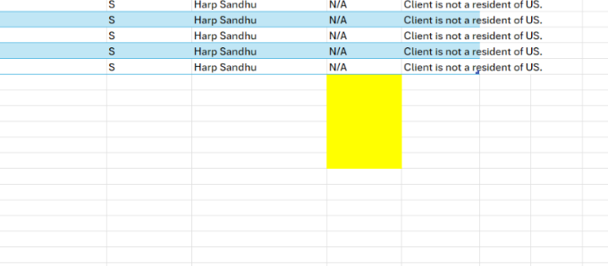
- Don’t change the comment from Pro Client (should be done with series 24)
  - 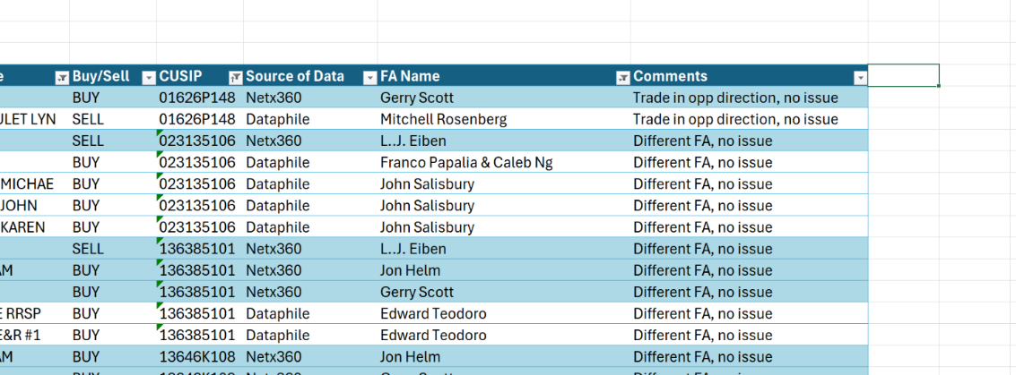

- Date: con
- Canary-learn-blue sky rules-any state-government

Pro client:
Sort Netflix on the top, dataphile at bottom

Task: Raw data pro client do it again

Excel file-info-author
Do the pro client part
July 16, 2025
July 17, 2025
July 18, 2025 completed

Last month of June

Go over daily trade review procedure to Ash

Email monitoring training from Roman

Yuan Training 2025-07-22
Tuesday, July 22, 2025
11:03 AM

1.Finra provide RJLU all mebers doing inspection remotely, Finra reacccess need of it
report to Finra every quarter the branch inspection

- Complaints
Order priority
July 31 due date
Client not happy with preogreess
RJLU certain process, advisor and team, bring to BM
We Investigete and report, last quarter highest numbe5r of complaint, back log
2 types
1,servise complain account opening,
- Sales pratice complain, client believe therir advisor are bridging some policies, not proper

2 stream licenses
Annual base training, good context with them

Building course Aug 4th

OBA report obligation to Finra

Format-autofit column width
Add to quick access bar

Pro client
Log in dataphile past in account nunmber-activity- bulk2

Portofolio review
Aggregation account number
HH Equity/HH Value

BD RT list-km excel
Original RTQ Score
Same tolerance and same address will be considered same house accounts
Household setup will not refresh every single time
Equity exposure, client buy pure stock will be 100% exposure, but if they buy different products
Household if is off side, there is growth between target and actual
If 17% which is 2% more than 15%

Task
Same portfolio name are same househould, make sure reporting target are same
Take all real colorful and update information in original RTQ list
Copy all data from 4 spreadsheet, then clean up date and ready for caoparison, make sure real color data compare with colorful data

Power Bi, add column
Split column, select comma, split into rows

not updated after 36 months, as per FINRA’s guidelines

Here is the system breakdown for your reference:

- Aggressive Growth: Target EQ: 93% -> 100% EQ Exposure Allowed
- Growth: Target EQ: 78% + 15% Drift Allowance -> 93% EQ Exposure Allowed
- Moderate: Target EQ: 64% + 15% Drift Allowance -> 79% EQ Exposure Allowed
- Conservative: Target EQ: 49% + 15% Drift Allowance -> 64% EQ Exposure Allowed

Please note that we allow a 15% standard deviation (Drift Allocation), which results in the system outlined above.

Hello Mitchell,

The currently RJLU Portfolio Review Program is still relying on Black Diamond to generated household portfolio data, so there might be some confusion around the number that we are presenting to you.

In fact, under a Growth risk category, your client can only go as far as 93% = (78%+15%) on Equity Exposure (including 15% Equity Drift Allowance). Essentially our review is based on the client’s signed RTQ (risk score/category) vs the Equity Levels in the clients’ HH portfolio/holdings.

Here is the system breakdown for you:

- Aggressive Growth Target EQ: 93% -> 100% EQ Exposure Allowed
- Growth Target EQ: 78% + 15% Drift Allowance -> 93% EQ Exposure Allowed
- Moderate Target EQ: 64% + 15% Drift Allowance -> 79% EQ Exposure Allowed
- Conservative Target EQ: 49% + 15% Drift Allowance -> 64% EQ Exposure Allowed

Please keep in mind that we allow a 15% standard deviation (AKA Drift Allocation) which results in the system above.

To give you more in-depth knowledge, Black Diamond does not allow for target ranges/bands (i.e., 70% - 80%).
Therefore, we had to elect a specific percentage for Equity exposures to build our targets and drift allowances, hence the explanation why there are differences between the Equity percentages seen on the RTQs and where the asset class targets lie on the system.

In that case, you client has 2 options:

- relance to bring the Equity exposure to just under 93%, or,
- to provide a new RTQ (scoring enough to upgrade the risk level) which hopefully would be able to accommodate the current Equity levels if that’s what they intend to do.

Should you have any questions, please let me know.

Kind Regards,
Vincent

Yuan Training 2025-07-23
Wednesday, July 23, 2025
10:47 AM

Touch base: How to Save email template

When blue sky violation happens
- Go to R:\Compliance Oversight\Blue Sky Violations Email
Create a new folder, put sent email in it

- R:\Compliance Oversight\Blue Sky Violations Email/Blue Sky Violation Log (starting September 19, 2022)
If information is limited in email, find more details is Netx360 Raw data from daily trade review

1-compliance-desktop

RJL Trading Restriction Meeting
Jessica VP Syndication
Trading restricted list
New pershing contact
Provide list of trading restriction

Factset
Search cusip
Security overview
Immediate issuer
Go to issuer page and find the cusip
Copy the cusip issuer

Box.com
Finra worm storage requirement
Exclusively in a non-rewriteable, non-erasable
Check log
Compliance oversight-checks log-usd checks log-fiscal 2025 check log

Rjnet to do
Canadian dollar check procedure
Cheque Deposit Procedure
Set up a meeting with Harris about what to upload on box.com

Referral Agreement
RJLU advisor
Split of fees between RJLU and RJL
Annual basis, each party need to agree
We ask branch managers to sign it, and renew next year
Every month, send referral agreement to FA
Compliance: Referrer's annual compliance report

Yuan Training 2025-07-24
Thursday, July 24, 2025
9:42 AM

Retail 1rj commision based

Institution business rvp dvp accounts

Member of sipc and finra

Register inverstment advisor re the largest business
Iar license Series 65 or CFA licensed as advisor
Fee-based businees to retail lient
2 products: non-descretionry
Decrestion: based your suiyably

Security based loan
Brocker chack, iapd
Series 66 condensed version of 65

Deliverry versus payment, receive versus payment

Introducing vs carring

Theme: oct 20th week

Portfolio review
Quartely task
Take email template and send to financial advisor
Supervison fuction, group by household
Same address, same tolerance will be grouped together
Mv of equity/ MV of the acct
How do we determine hh is offside

EQ is calculated using a

4 obligat9ions
Duty of care best interst
Fiduciary higher obligation best soultion, any other service inquire about, best ability, for fee based commison
Document integrity completeness, original

Risk task questionare
Commision based, rtq
Feed based, p74, rebranded
Govern customer

Exempt relief
2012 exemptive relief from canadian regulator
Operate from canada

Rjlu

Dwcewtional to us

Yuan Training 2025-07-25
Friday, July 25, 2025
12:45 PM

Textjoint
Iferror( index, Match)
Pviot Table

Branch names
Rows:bm name, branch name, rr/IA, months
Values: count of security descriptions
Click branch names and RR/IA

Next step for Branch allocation data,
combine all data to one sheet
add branch name
create a pivot table that make sense,
analyze the data to see if any outliners or create a heatmap that make sense(see the workbook that previously shared with you)
Outliner means if one sigle branch is more than 25% of the total work load

Yuan Training 2025-07-28
Monday, July 28, 2025
10:05 AM

📘 Blue Sky Compliance Summary
Exempt States for Blue Sky Laws
- California (CA)
- Montana
- Arizona
- New Mexico
These states do not require registration under their Blue Sky laws for certain securities offerings.

- On Toronto Stock Exchange (TSX)
- Net asset

FACT SET - PROFILE- EXCHANGE: TORONTO
FACT SET-Financials-Balance Sheet- Total Shareholders' Equity see if larger than 25 million

Canari -Foreign ready market

https://brokercheck.finra.org/

<<Compliance_Low_Priced_Securities_Summary_FINAL.pdf>>
Low price securities deposit R:\Compliance Oversight\LPSQ approvals

If DTC eligible is no, then it need to be phy cert

Irrevocable Stock power and physical certificate together
Stock power Is on Rjnet-Home-operational forms and procedures

Total shares outstanding: yahoo finance-statistics and profile
Sedar+ canadian regulatory file : chek missing or late
If it's us company, search edgar sec fillings
Folder:R:\Supervision\Low price large share dep log
Go to sedi to check client is insider or outsider
Source of wealth: netx 360-document center-new account form-USA Patriot Act
Occupation: board director
Check If securities be restricted to RJF

Send an email to FA once branch manager approved
Log
Search account number in Compliance oversight-LPSQ approvals folder
If no folder, create one
Low priced large share deposit due deligence spreadsheet log excel

RSTK is a label used in client accounts to indicate Restricted Stock.
LPSQ is a compliance form used when a client wants to deposit or trade low-priced securities (often under $5 per share).

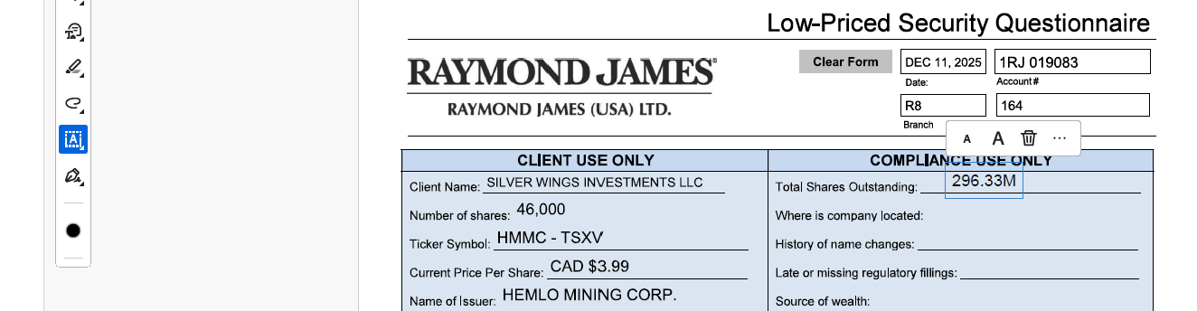
🗂️ Document & Form Retrieval
- Obtain Irrevocable Stock Power (if they only require deposit then they don’t need to provide)and physical certificate together
- Stock power form location: RJNet > Home > Operational Forms and Procedures
📊 Company & Share Verification
- Check total shares outstanding: Yahoo Finance > Statistics , find total shares outstanding
- , go to company name+tsxv for more data
- OR FACTSET-Financials-reported shares analysis
- For " where is company located", Canadian companies: check yahoo Profile
- History of name change: search company name+ name change
- verify regulatory filings via SEDAR+ (check for missing/late documents), enter company name in " select profiles to search on" others things unchanged and click search
- Check if the company in SEDAR+ is Cease Trade Order
There are 4 files we need to check: Interim financial statement, interim MD&A, Certification of interim filings CFO and CEO make sure these 4 files exist
- For U.S. companies: search EDGAR (SEC filings)
- Determine insider/outsider status via SEDI
🔎 Account Due Diligence
- Occupation: New Account Form-Employment status and industry affiliations- occupation
- Check source of wealth: NetX360 > Document Center > New Account Form - step 3. USA Patriot Act information)
- Confirm whether securities are restricted to RJF
- What percentage of outstanding shares do you own? Go to netx 360 positions and find all same name shares, then add all and the shares on form together, then divided by total shares outstanding: question 7 total shares you own divided by total shars outstanding on the form
📨 Branch Workflow
- Use template Send an email to FA after Branch Manager approval
- Log details accordingly
📁 Compliance Folder Management
Save in the folder:R:\Compliance Oversight\LPSQ approvals
📈 Tracking Spreadsheet
- Update/maintain: Low-Priced Large Share Deposit Due Diligence Spreadsheet (Excel format)

Read documents provided by FA and find out:
How did client acquire the shares?

Read reqstion 10: check physical certificate

Check if there's past deposit
Check legend free, where client get the warrant

Documents and Review Process
- Required Documentation
  - Scanned copies (front and back) of physical stock certificates, ensuring legibility.
  - A completed Low Price Security Questionnaire (LPSQ).
  - Electronic signature summary (if applicable).
  - Supporting documents (e.g., subscription agreements) showing how the shares were acquired.
- Compliance and Approval Steps
  - RJLU Compliance reviews all materials and may contact the FA/client for any needed clarifications. LPSQs and supporting documents are saved in our shared drive.
  - Once approved, the Branch Manager reviews all supporting documents and signs the LPSQ.
  - Certificates are then sent to Pershing Custody for final review. Accepted securities are deposited into the client’s account.
  - If restricted, the position appears as RSTK in client’s holding.
  - When legend-free shares are issued, RJLU Compliance restricts the account with a note specifying that these shares: Cannot be traded on any U.S. market. Cannot be knowingly sold to any U.S. resident. Cannot be transferred without Branch Manager/Compliance approval.

Sending to Branch Manager email example:
Good morning Milene,

Please find attached the LPSQ and related supporting document for your review.

Client Frederick Morton, P74058028, requested to deposit 28,111 shares of Yangarra Resources Ltd, which is currently trading at $0.76 USD.

Client is currently an insider and a board director of the issuer. From the Sedi report attached, we can confirm that the client acquired the shares from exercise of rights. We also got confirmation from the issuer that the shares issued are unrestricted and fully vested. The deposit has been reviewed by the RJLU CCO, Ash Chester, and compliance has no further concerns regarding this deposit.

Kindly review and provide us with a signed copy of the LPSQ, if approved on your end.

Kind Regards,
Vincent

Sending to FA email example:
Good afternoon Haani,

The LPSQ has been reviewed and approved by Branch Manager. We are good to proceed with the deposit.

Please ask your client to complete the following instructions to deposit the 20,000 restricted shares of ECare Solutions, Inc,:

The client is to send to Pershing via FEDEX/UPS all the following original documents:

- Original Stock Certificate (please have the client’s RJLU account number in the top right-hand side of the certificate)
- Stock Powers – signed by the registered holder with a wet signature.

Pershing’s address to receive those documents is:

Attn: Securities Receive Department
PERSHING LLC
1 PERSHING PLAZA
7TH FLOOR CUSTODY GROUP
JERSEY CITY NJ 07399

Kindly ensure to provide me with the courier’s tracking number ASAP.

Kind Regards,
Vincent

Drs: direct registration system
Physical common share certficate

Rjnet: Restricted securities table

NETX 360: Accounts- items for attention

<<RE_ LPSQ - Timothy Bean & Helena Bean 1RJ018424 - Osisko Development Corp_ 55_555 Warrants .msg>>

Tuesday, July 29, 2025
9:51 AM

ADR: american deposit receipt

Us tres bill: exempt

Wednesday, July 30, 2025
10:05 AM

Dashboard training
Point of contact enterprise data team, Daniel Faseyi, Jenni Myles
Service now-Order something-enterprise data services

Blue sky:
Certificate deposit
e.g. ally bank
Ally bank is a member of the federal deposit insurance corporation
The CD is FDIC insured.

Yuan Training 2025-07-31
Thursday, July 31, 2025
1:58 PM

Transfer agent

3 reports on netx360
Commission analysis daily detail report
Large options positions
Short interest period

Account n

We

=LET(
p, TRIM(A2),
kA, TRIM('Offside Analysis'!A$2:A$10000),
kB, 'Offside Analysis'!B$2:B$10000,
m, FILTER(kB, (kA=p) * (kB<>""), ""),
IF(A2="","", IFERROR(TEXTJOIN(", ", TRUE, UNIQUE(m)), ""))
)

=XLOOKUP(A2,'Offside Analysis'!A:A,'Offside Analysis'!C:C,"")

=IFNA(XLOOKUP(A2,'Q2 Reference'!A:A,'Q2 Reference'!H:H),0)+3

=XLOOKUP(A2,'Q2 Reference'!A:A,'Q2 Reference'!L:L,"")

Yuan Training 2025-08-01
Friday, August 1, 2025
12:57 PM

1.Meghan irmler template can be updated
Go to steve any request update, 30 agreement in a month

2.do it every year
Go to jessica, run it by sonia

3.fully get to course, make sure wsp
Scc market
Rule per jessica,
Reg bi
Next year internal aduit

4.send to Ash, highlight importance

Redbi

Compliance h drive, rfi.2025.finra

Meeting with Katy
Junior associate from canada team
Finra contacts sero
RJLU has nothing
What came extenally
Exclude internal communication
Half of these from canadian side
50 thousand from office
PST file put into box.com
Give index of subject of email, and pst file
We're droping, all responses give to sero, sero gives to finra
Why are they coming to us and digging
Finra sec morgan louis
He receives shares from alska as commision
10 days to answer
Everthing priviledge and confidential
Use canadian email to connect US and Canada
EXECUTION happens for client
P74/p75/1rj
Rjlu vs rjl
Alska reception

  - Fee-Based Accounts
    - Non-Discretionary Managed Accounts
      - Adviser may accept unsolicited orders if the trades are suitable for the client
      - Investment recommendations must be unbiased and based on information provided by the client
      - RJLU provides full brokerage services included investment advice, account reviews, and trade execution
    - Discretionary Managed Accounts
      - Portfolio Manager is authorized to exercise his/her discretion to make investment decisions within the framework of the client’s overall investment objectives
  - Commission-based Accounts
    - Adviser may accept unsolicited orders if the trade is suitable for the client
    - Investment recommendations must be unbiased and based on information provided by the client

Tuesday, August 5, 2025
10:13 AM

FIXED INCOME-BLUE SKY
ENTER COMPANY NAME
GO TO FACTSET CHECK ISSUER AND PARENT

Wednesday, August 6, 2025
11:08 AM

P74,P75,1RJ are client account
Account naming system
On the dataphile side all accounts are all pro accounts
RBC always look for common shares

Folio means bulk trading

Follow up with Ash: TIPWX Redemption

Compliance daily monthly procedures
Restricted list
Excel-list of securities
Assets rule definiation: AJR, account:P74
Click search, if account not appearss,
copy and paste symbol/CUSIP
Repeate with P75 AND 1RJ
It's 3 times
If it's wrong, go to markets page, enter cusip, security search,no result means security is not on Pershing, security is not set up on Pershing

2025-08-07
Thursday, August 7, 2025
11:43 AM

Blue sky securities
1.check if these accounts are restricted
2.then check blue sky
Go to restrictions-RJ Net report
Broadridge web desktop
Restriction: no solicited buy and sell
Expert market definition: only visible to professional map is grey
Grey market: no price

2025-08-08 Touchbase
Thursday, August 7, 2025
2:58 PM

I’ve been thinking about how we’ve been working together lately — and I feel like we might need to tweak a few things. Right now, it kind of feels like we’re just cruising on autopilot. Things are getting done, but we’re not really improving how we work or making things more efficient.
You’ve been solid on the daily trade reviews — that’s been a huge help and definitely takes a load off my plate. But when it comes to our touch base meetings, I think we could use a bit more structure. Lately, it’s felt like we’re just chatting about whatever I happen to remember, and I don’t think that’s the best use of our time.
Maybe we can:
- Set up a shared agenda or notes doc to keep track of what we want to cover
- Have a simple structure for each meeting so we’re not just winging it
- Track action items or follow-ups so things don’t slip through the cracks
Let’s chat about this in our next touch base and figure out what would actually help us work better together. Open to your thoughts too!

- Questions about pro client(dataphile), blue sky(fixed income part)
- If preferred share is not blue skied in all states, check for the common share. If the common share is okay, then the preferred share is good. I don't understand that part, yesterday you told me check only common shares
- Treasury notes do not need to be checked, as they are issued by the government. What are other things that issued by government that I can write exempt
- Treasury bills and bonds and notes all ok. Provincial level, issue bond is exempt.
- Usually Canadian listed ETFs are not blue skied in the US, but WA has an exemption. Why for ETF, WA is a special state
- Employment letters
- PTO days/in office date

Send an email to Adriana
Approval for take sie exam

Contact stephenie, change location in the system to 100 yonge also give her requirement of ohip's employment
Manulife change to home address

10-10：30 check roman‘s work

Monday, August 11, 2025
10:13 AM

Sara Minatel& Jessica NG
RJL side restriction
After add or delete, do the log

Ask ash time bi-weekly or monthly to have a touch base

3 reports on netx360
Commission analysis daily detail report, if there's anything, save in the folder
Large options positions
Short interest period

To kale
Cc rjlu info

Tuesday, August 12, 2025
11:05 AM

Weekly meeting
Look at meeting, adopting: ok with meeting minutes

Email monitoring training with Harris

Once FA reply, change offside to pending

Big FA: Luc Desbiens, Brett Graham

2025-08-14
Thursday, August 14, 2025
11:01 AM

Email monitoring

Click unreviewed-message review
Pershing identifiable information
PII: personal identifiable information it's client information
Pre set comments

If it is complaint:
More-retrieve to inbox

PII:
There is a list that it's ok to send client information e.g.TD

What is the difference between these two divisions? Is it the source of the emails is different, or that the content is categorized differently?

Netx360
Accounts -all accounts-accounts-
453-john mclean
Document center

RE: Crypto ETF RJLU Q: Remind Ash on 8/15 crypto securities
Open exam window
Register on Wednesday
Schedule people meeting, and give them lists, provide procedure and

Friday, August 15, 2025
4:10 PM

Change rtq
Check and change account numbers

RJL trading restricted list
Monday, August 18, 2025
4:37 PM

RJL trading restricted list
From sara and NG, Jessica
1-compliance-restricted secuities -RJL TRADING restricted list
Excel : RJL TRADING REATRICTED LIST- UPDATE only addition and deleted, and save it.
Copy the name in factset, check the cusip and isn
Netx, service, opt center, compliance tools- restricted/watched, and paste information, comment is the date, and enter it
Go to original email, and forward it to compliance RJLU, "below updated "

Document Integrity
Tuesday, August 19, 2025
1:34 PM

Netx360 use account number
Accounts -all accounts-accounts-
453-john mclean, every doucument
Left side-Document center, read documentation
Only check Ever green documents
Check signature time and page bottom time are same or not
Form generated time must before signature time
Index value account number is same as file's account number

Accounts-PROFILE-Single account
Document center
New account form, adoption agreement, account transfer form, all transfer form, management fee authorization

bryn krakauer
NAF: new account form
Compliance oversight- vincent working folder
The right one blank box enter 449, the use click download excel
W9 is tax form

Sonia and abdel can know the situation, others can't, no disclosure
- Wet, compare, 100% same then it is problem
- Generation time

Blue Sky Violation
Wednesday, August 20, 2025
10:00 AM

When blue sky violation happens
- Go to R:\Compliance Oversight\Blue Sky Violations Email
Create a new folder, put sent email in it

- R:\Compliance Oversight\Blue Sky Violations Email/Blue Sky Violation Log (starting September 19, 2022)
If information is limited in email, find more details is Netx360 Raw data from daily trade review

1-compliance-desktop

Proofpoint Training
Thursday, August 21, 2025
1:13 PM

What information caused email to be flagged
Ssn, date of birth
Ppi personal identification information

Compliance - compliance help- proofpoint admin- TLS Domains list

Check the email first

1-complaince-email and social media monitoring

LOPR Position Reporting
Thursday, August 21, 2025
3:52 PM

AIC: acting in concert
Daily run every morning
Ops center-acgp-account group

Friday, August 22, 2025
11:44 AM

Call help desk, ivanti not update the address, you're added to the Rjevent, some packaged sent to vancover and need to update it.

Branch Inspection
Friday, August 22, 2025
3:41 PM

RJLU:/Branch Review-RJLU

Every 3 years cycle
Special situation: recommend by CCO

Scope: RJLU

Teamwork folder

Monday, August 25, 2025
10:48 AM

RTQ Netx360
CHECK:AMBASSADOE NON check if anything update in December
PROFILE-PARTICIPANTS AND BENEFICIARY
Go to portfolio review folder

Management fee authorizatiobn

NETX360 Training
Monday, August 25, 2025
2:01 PM

Servicing
Ops center
Service center: submit request to Pershing
Work corner

Analytics
Acting in concert groupings for large
All reports-COM044D0

Tools

Analytics- report builder

archive
Wednesday, August 27, 2025
11:15 AM

Message attributes part
Flagged-identified with flag

Rule
Specific Rules
RJLURR

Only look at 5 rules
Write in issue management
Clear-clear with comment

PII: personal identification information

If rjl - more- retireve

1-compliance, email and social media monitorinh

Wednesday, August 27, 2025
3:54 PM

Netx360: find ambassador and found all accounts
Check participants/beneficiaries
Positions

Vincent suggested me to schedule a touchbase on a regular basis to connect.

Schedule with Roman: 3 sessions of email monitoring, each session 1 hour
Set time in october with vincent: go over check box log

Portfolio needs to be set up according to risk tolerance, for any drift we have 15% threshold on the equity side,
Currently all the accounts we listed that we sent to you are all offside by more than 15% on the equity side,
These accounts either need to be rebalanced back to risk tolerance or if the client risk tolerance has changed this needs to be confirmed with clients and new risk tolerance questionnaire would need to be filled out

Email monitoring
Wednesday, September 3, 2025
2:30 PM

IF IT'S RJL VIOLATION, Forward to RJL: COLLIN BEARDMORE

Touch base with Ash
September 3, 2025
4:07 PM

2025-09-03 3:57 PM Touch base with Ash
- Connect and Say Hi
  - Thanks him for the touch base,
  - You want to connect and get to each other a bit better
  - You are happy with team, still excited to learn and to be part of team.
- Your onboarding
  - Big progress, this is a good time to chat
  - Next focus is on grow with RJLU, to be a bigger part of the team.
  - It was nice meeting Harris in person, wish to have a chance to visit Van office
  - Exam, Vincent will send you my request about PTO, 11, 8-10 as my pto.
- Your interest
  - There are a lot pride related events, you appreciate that
  - Going to Shooting range.

Touch base
Friday, September 12, 2025
10:32 AM

Professional photo
Reimbursement
Series 7 study material

OBA: 160 hours change to 2 hours

Tuesday, September 16, 2025
2:58 PM

5123 filing needs to be done with FINRA. regulatory on finra gateway private placement with rjlu involve deals by RJLU CLIENT maket by RJL. RJL syndicate department, distribuion of prive placement, if security is not registered in US, shares can be sold in private placement, The exception they can do regulation D exchange security act. WE HAVE CLIENT WANT TO do private placement.

4513 mail room have a test of part of complain procedure.

5282 certification if I'am involve in research, RJLU: retail and instituantial clients.

OBA
Wednesday, September 17, 2025
11:08 AM

RJLU employee do OBA for RJL
Everyone needs to sign OBA

Secondary approval from compliance side, other staff go to registration, supervision do the approval
Folder: obas and titles
RJFP is within RJL scope

Review past 2 month

7275906283

Low Security Deposit
Wednesday, September 17, 2025
2:54 PM

After Bm APPROVED, we log it
Folder:Low price large share dep log

I have reviewd and signed off- from BM means it is done

Low price large share deposit due dilligence spreadsheet
If account is P74, we do not charge review fee

Save all folders in LPSQ approvals once completed

Task :Log the 5 accounts

Fater finish log, go to Netx360 past account number profile - transactions

If client first time for the low price security legend is not removed and it's 1RJ account, will charge client 360 dollars
If it's P74/P75, no fee

CAD and USD Cheque Deposits
Wednesday, September 17, 2025
3:20 PM

- Need log all check they received
Folder: check logs- usd or cad

- Check need to leave branch next day before noon time (PST time vancover)to Pershing

RJLU receive a scan copy
Log to tracker

Branch Inspection
Thursday, September 18, 2025
11:30 AM

Branch Inspection Procedure_uodated_06 23 25

Pick few accounts number
Netx 360- account-transaction-transaction type security transaction

Reports-daily review-abdel adil-2025-april
Address change- document center- notifications

file: VW Brach Inspection 2025 Schedule
Oct27-31
NOV 3-7
Calendar overly

Branch inspection booking email template
We have multiple branch inspection going same time
Compliance will…

Best Execution Requirement
Thursday, September 18, 2025
4:03 PM

It's FINRA requirement
Help client with best benefit

Broker's obligation to take reasonable steps to obtain most favorable overall execution outcome for a client.

SEC 606 report
Quantitive trading, high frequency trading
Trade billions every single day

RJLU + Pershing
Service provider
We give you order, you give me slighter better price

Pershing has mechanism to find the best order

Percentage tracker: what percentage achieve the best price improvement

If there's any deviation
95%
If 10% deviation, if jumps to 100% then ask Pershing why
Significant drop in the price improvement

There are 2 data sources

Pershing provide all the data, Put that on our tracker:
https://www.orderroutingdisclosure.com/
1-compliance, policies, procedures folder
Type in: RAYMOND
Export in exl, download it and give it to copilot, as export an excel for you
Then go to R:\1 - Compliance\Best Execution, rule 606 disclosure

The second data source is on NETX: tools- resources, search execution quality scorecard
Enter data on the excel execution quality scorecard

R:\1 - Compliance\Best Execution

Use matrix every quarter, to see if there's outliers
1-compliance-best execution
FINRA 5310

Excel: Best execution workbook
Copy and paste data
10-15% outlier

Procedure will be in (training and onboarding folder)

Then calculate 5% deviation matrix

Portfolio Review
Thursday, September 18, 2025
4:59 PM

If recalculate, log in NETX360, calculate equity/all amount

We look at equity exposure instead of rating of the individual positions

We have completed LPSQ review. we escalte this to branch manager for approval.

Thursday, September 25, 2025
10:59 AM

Hi Jennifer, this is Yuan calling from RJLU Compliance. I received your email regarding the portfolio review. Thank you for sending over detailed updates after the client meetings.
I just want to follow up and ask: Are there any conclusions or next steps regarding portfolio rebalancing or changes to the client's RTQ?
Each portfolio should be aligned with the client's documented risk tolerance. As part of our oversight process, we apply a 15% threshold for equity allocation drift. Currently, all the accounts listed are exceeding this threshold on the equity side and are therefore considered offside.
To bring these accounts back in line, one of the following actions is required:
  - Rebalance the portfolios to reflect the client's existing risk tolerance; or
  - Confirm if the client's risk tolerance has changed—in which case, a new risk tolerance questionnaire must be completed and documented.

Tuesday, October 7, 2025
10:32 AM

Prudent process
Fee based account for FA
Biggest one: Firm element, needs assessment
- Retail advisor PCG
- Institualal sales personal
We identify risk document integrity. Comes from assistant and institutional. To branch modelues,

Know the content,
Coming up with population,
Gap between email address and user id

First go to RJLU Roster

Gp back to master report, check log in and email address

PCG ECM copy the CRD number , go to master control F

NRFI-FE

Manually adding restricted securities
Thursday, October 9, 2025
1:06 PM

1RJ this symbol was already assign, move to other cusip, if not check P75 and P74
P74
P75

You specify wrong cusip/symbol, nothing on netx 360, move to next one

Document Integrity on RJL side
Friday, October 10, 2025
2:30 PM

Dataphile
Client master- single account
Postedge

Highlighted yellow

Draft policy

Check best excecution files

Inbox management
Go through low price securities cases, schedule training
Inbox: low price securities

note
Thursday, October 16, 2025
9:42 AM

Inbox management

Low price security and physical deposit training

Go thorough work allocation

HRS Reporting
Thursday, October 16, 2025
3:58 PM

Every quarter
Means: Higher risk supporting
Enterprise level been restricted. Individual teams cannot override it
Often no
We can't give exemption

No restricted securities from RJLU during what time period

Only send to James if the restricted securities are restricted and discussed by RJL, RJF and RJLU.

Thursday, October 16, 2025
4:35 PM

compliants
Friday, October 17, 2025
11:05 AM

Categorize compliants

Portfolio Review initial step
Monday, October 20, 2025
3:15 PM

Portfolio review data Q2 2025

- Go to netx360, analytics-report center-all reports- search the one called: PR holding data EA173522

- Check worksheet holding data, the default form is not totally correct
Change the formula:
Start with P74
Start with P75
Compare all categories with the holding data spreadsheet (except J,K,L)

NEXT, generate excel

- Copy everthing from report that generated and downloaded, then paste to the holding data sheet (from A to I)
Make sure clear all content before copy and paste
J,K,L have formula, will be automatically calculate

- Go to offside analysis spreadsheet, automated update
Compare with past note to see if update with reporting target
Offside analysis Column H, data is imcomplete. Reporting target is not correct, if there's anything changed, update on the spreadsheet.
H drift larger than 15%: Everything true

5.Go to pivot table and refresh
Pivot table id from offside analysis

- Summary Data
Offside accounts: Offside Analysis spreadsheet, select drift larger 15% True, crtl+shift+ down
arrow, and see the count number on right bottom side.
Offside HH: Pivot Table spreadsheet, click PivotTable Analyze, change data source, see if the range is similar to the all "offside analysis" spreadsheet, then right click refresh, then select all "portfolio name" to see the right bottom side of the count number
P74&P75 Accounts: Copy and paste account number from holding data, paste in new spreadsheet, then select "remove duplicate", see the count number

=F18-C18-0.15

Document integroty
Tuesday, October 21, 2025
12:56 PM

Open outlook deta

Thursday, October 23, 2025
3:18 PM

Rule 144 QIB definition
Restricted security table

RJ NET USA, DEPARTMENT- COMPLIANCE-RJA CENTRAL DIVISION

Pershing:
Email: actimize access within Netx 360: 3 email address
We have want to deposit back, we understand new policy, but client has that transmiital of letter. Can we get expemtion?

Record inventory
Thursday, October 23, 2025
5:11 PM

- Combine past and this year's record

Location:R:\1 - Compliance\Books & Records - Compliance Records Champion

Compare 2024 and 2025

Records inventory- 54 records

1-compliance- RSL-FINRA- RSL-FINRA -RJLU FCM GRC list

Holdings (T-1)
EA153712
How to build report - training

Legend removal
Friday, October 24, 2025
11:10 AM

At least 6 months
Current public information

Custody legal transfer

Go to LPSQ approvals

Client name, then get account number

Rjlu folder, supervision , low price larage ahre dep log,
Ifnothingm , the deposit is not goes to RJLU
SECURITY DEPOSITED AT RJLU
7 dollards not lpsq

Deposit security , do drs transfer,help to do legend removal

This orice is not lpsq, we can do DRS. Legend can be removed, do rjlu deposit first, or outside rjlu. Please be advised regend can be removed at least a year, based on 904 cliednt need s to provide folloiwng materials

  - This security is not classified as LPSQ, therefore a DRS transfer is permissible.
  - If the client is requesting legend removal, the shares will need to be deposited with RJLU first.
  - Once deposited, Please be advised that the legend may be removed after at least one year.
  - and the request meets the requirements under Rule 904 (Regulation S).
  - For a Rule 904 legend removal request, the client is required to provide the following documentation:

  - Stock power
  - Seller’s Representation Letter
  - Seller’s Declaration Letter
  - Broker Letter

Pershing does have physical certificate, they are going to pack everthing and send to transfer agent like CIBC. They don't talk to forein
  - This security is not classified as LPSQ; therefore, a DRS transfer is permissible.
  - If the client is requesting legend removal, the shares must be firstly deposited either with RJLU or outside of RJLU, subject to compliance review and approval.
  - Under U.S. law, Rule 144 under the Securities Act of 1933 permits legend removal not in connection with a sale or transfer only if the shares have been held for at least 12 months and the holder is not an affiliate of the issuer. Please be advised that legend removal may be considered after the applicable one-year holding period has elapsed. In the case of a seller who is a dealer or a person receiving remuneration, a resale may not be knowingly made in the United States.
  - For a Rule 904 (Regulation S) legend removal request, the client is required to provide the following documentation:
    - Stock Power
    - Seller’s Representation Letter
    - Seller’s Declaration Letter
    - Broker Letter

-

Branch Inspection
Monday, October 27, 2025
10:54 AM

Write report
Wrap up report

Schedule RJLU program overview

Crytocurreny trade approval

IFS Branch advisor is also branch manager

Wednesday, October 29, 2025
10:42 AM

ot

Wednesday, October 29, 2025
11:54 AM

Netx360
Description: restricted
Go to transactions, search for activity description to see if there's RSTK
GO TO LPSQ folder and search for account names
Go TO DOCUMENT CENTER, search for pending paper
Legal transfer

RSTK
Friday, October 31, 2025
1:57 PM

NETX360
TRANSACTIONS
Looks at activities

Make sure legend rreomoval is approved
Read the file: legal transfer

Steps:
Put comment in the netx
Click upper right to edit

Pace block
Ops center
PACE- FLAG

Go to supervision-low priced large share deposit excel

Pershing LOT not received situation
Monday, November 3, 2025
1:57 PM

Netx360 Items for Attention Physical securities pending documentation

Request extension:
Service- service center-custody-extension request

Titles
Monday, November 3, 2025
2:14 PM

1-compliance - OBA&titles- RJLU acompliance bulletin 20-01

Legend removal
Monday, November 3, 2025
2:19 PM

Pending paper and legal transfer to see block removal
Look at the legend

Check if Securities changed or not

If securities restricted and not restricted are mixed together.
Legend put back, and remove together

Netx notify pershing about incoming documentaion
Tuesday, November 4, 2025
10:09 AM

Sevicing - SERVICE center- custody- tracjing incoming socumentation

Incoming Lot
OVER NIGHT ups

1ZH4A6190144133917
Hi team,
The Letter of Transmittal (LOT) was sent on
November 3 and is currently on its way.
Thank you.

Wednesday, November 5, 2025
2:57 PM

Drs - direct registration statement

Portfolio Review Q3
Wednesday, November 5, 2025
3:13 PM

Equity% compare with RTQ

Next week meeting: How to set up report on NetX next week Tuesday 3:00 PM

1.Grouping as household level
2.Updated Risk tolerance

HH all RTQ should be same

Build our data base
2 years data improvement and maintenance

Same Household criteria:
Address match
RTQ Same

Powerbi: Fuzzy match
Python

Task: Double check data, fill out form

Accurate information

BM Volume
Friday, November 7, 2025
11:45 AM

Merge
Filter by fa advisor\

Select unique "Vincent" and "1 A" both

Complaints
Friday, November 7, 2025
1:23 PM

Sharon Keenan
Privacy issue: check Email communication is to through safety
As conservative investor, she never heared from them.
Team not respond back to her.
Review: team's poor communication september 11th to 18th
Check what she did to contact raymond james
- Communication
- Privacy related, how information sent to her

Dawn Thorn
Her husband is the one contact
See if funds are recovered, Account transfer

Courtney Robinson
Why transfer takes so long, confirm transaction is complete

Ken Campbell
Only second one is RJLU related
Review emails
What advisors provide to content, what are the content

Patricia Cucman
Error distribution
Follow up with operations

Andy P Harris will work on that

XLOOKUP(Draft!A2,'Offside Analysis'!A:A,'Offside Analysis'!C:C,"")

RE: RE: Aether Global Innovations Corp. - LETTER OF TRANSMITTAL (1RJ017020)
Monday, November 10, 2025
11:29 AM
Accounts - items for attention - physical securities pending - documentation

profile

Send to custody denese:
Confirmation loa so they already inforemed
Original email about deposit

Check accounts - all accounts - Items for attention (every day)

Deposit low price security
Monday, November 10, 2025
3:21 PM

Physical ceriticate
DRS
Compare theses 2 differences

- Price if below 0.5
- Wheher thois security ois restricted security check on RJ Net Report

Not restricted bo wither way
If it's restricted, it can only be physical certifate, if it's not it can be both

If DRS, Go to account transfer, and client need to work with operation.

If client going to do Physical ceriticate, client needs to do due diligence with compliance.
No restricted security , no low price security, then we can do it

Ask for exempltion, we escalated to pershing denese and AML.

Low price security is always pershing aml

Hello Frank,

As of July 30, 2024, Pershing will no longer accept physical and electronic deposits of securities priced less than 50 cents per share (USD). Pershing’s new policy on low price security doesn’t cover the unsolicited purchase orders.

The scope of pershing policy for low price below 0.5 is covered electroninc. Unfortuanately Pershing is unable to accept it.

Notification Only: Higher-Risk Securities
Monday, November 10, 2025
4:15 PM

Trading restriction list

To see if prohibition reason is sanction security or not

Cannabus related: should liquidate all

1.First question to anything: is it restricted security? Go to RJ net report
- Go to everyday's restriction list
- Next, go to canari, if it’s pink limited market it is restricted

Service Center Request
Wednesday, November 12, 2025
12:28 PM

Pershing
Service center

Worthless position
Tools- learning center - worthless- remove a worthless securitty from a client account
Remova patrick

Weould would be required to remove wothless account ? Could you let me know

- Thank you somuch for
- After client sign it, what are other procesure?does it nedd to send to operation? setps what are the process

CO LETE THIS FFORM, THEND TO OPERIOAN AND COMPLIANCE WE'RE are gping to process

Next week book a portfolio review session

We handled over to operations and operations is going to processing it

Client

Complaint
November 14, 2025
9:30 AM

Complaint

TIPWX Redemption. 25-12

Find out the timestamp of the action, see if we can support client claim
- Download the pst file,
  - Emails who asked for what, who asked for the plan,
  - When is the first meeting
- Transactions
  - Timing and what to do
- Findings, get a report for this, write up a report.
  - Client wants to get the money that was lost

For Elieen Kelly
Know more about case and investigate a bit more about It
- Communication, know what was discussed and what was the plan. Between eileen and chris raper
- Transactions, know more about the transactions, what has been done.
- Vincent: write a report. - Set up a time with Kelly

For Chris Omalley,
Have a look at the portfolio,
Train Roman and Yuan to have a look at the transactions. Need to understand holding period returns.
Compare year to year returns. Look at client's risk profile, dec 2021 statement, see the portfolio set up, 15% allowance. Do the return calculations. Then do a review on this.

Filling if for Harris to do

For Sharon Keenan
- Prospectus is concerned about the privacy
- Also Harris already called the client
- Client not happy sending things via email. Need to check how L.J is communicating with client, or was the email was protect or send securely
- Client never hear back since sept 18, she called, no calling back, no good regular contact.
- Client send emails to LJ, but has no response.
- Chris mills is slow on the response
- Between sept 11-18 what client did to contact client.
- Harris to download the pst files
Details deleted, we can propose another advisor

For Down Thron P74030217

- Husband was not happy about the transferring process, wire was not received, wiring fund from Canadian instituted, the way that Charlie interacted with the client.
- Advisor created question in
- Need to see if the fund is recovered. Just no convenient, return the wire fee or any other fees. See what's the account and return some fee from there
- Work with Operations to forward all the emails to us to review.

No fees are charged Q3 onwards (except the standard Termination fee)

For Courtney Robinson P74040935
- Account transfer is taking more than 2 month, go to service center about it, check what is the issues
- Work with Operations to forward all the emails to us to review.
- If the client does not ask fees, we don't need to cover

don’t see transfer for this account in 2025.
Standard asset based fees applied

Acknowledgement letter send to the client. send it encrypted.

Sales practice,
For Kend Campbell.
- What advice was provided to the client,
- Call the adam and know his story, know where it is wrong
- Never a relationship, maybe another advisor

For Patricia Cucman P74002331
- IRA distribution, RMD didn't go through on time, communication, and what occurred
- No instruction, a month late, It happened multiple times, look into more than 2 times, what's the reason for the past multiple occurrenceZ
- Get the problem, and forward all the emails. Operations

This account with Periodic distribution setup quarterly.
On Sep 23, the account does not have enough liquid fund, hence per periodic setup, partial of fund is distributed.

For Andy pliaras

Monday, November 17, 2025
10:07 AM

Good morning Adam,

Hope you are well.

- You do not need to provide a certificate of completion for the Reg Element CE, a I can see from your FinPro profile that you have completed your credits.
- Regarding the CIRO CE credits, you can leave that to us. After October 31, 2025 I will sending a list of those individuals who have completed the Reg Element to our Registrations team so that they can add 1 CIRO CE Compliance credit for those who have completed the course.
- You do not need any external CE credits for FINRA.
- See above answer. All you are required to do for this for this course is to complete it, which you have done. I will do the rest.

Please let me know if you have any further questions or concerns.

Regards,
Harris

Harris Ayyub
Senior Manager, RJLU Compliance

Raymond James (USA) Ltd.
2100 - 925 W. Georgia Street | Vancouver, BC | V6C 3L2
T: 604.654.6577 | F: 604.654.7238
Toll-Free: 1.877.363.1024
harris.ayyub@raymondjames.ca
www.raymondjames.ca

From: Adam Beaudin-Ball <Adam.Beaudin-Ball@raymondjames.ca>
Sent: Thursday, June 12, 2025 4:55 PM
To: Compliance RJLU <Compliance@rjlu.com>
Cc: Adam Beaudin-Ball <Adam.Beaudin-Ball@raymondjames.ca>
Subject: RE: Completing FINRA Regulatory Element Training by October 31, 2025

Hello,

I have a few questions regarding FINRA CE credits as this is my first full year of registration:

- I didn’t receive a “Certificate of Completion” for these Regulatory Element Continuing Education (CE) Training courses. Is the attached sufficient?
- Please confirm if I read the below correctly that I load this plus additional CE credits through the CIRO CE credit portal along with my Canadian CIRO CE required CE courses.
- How many additional external CE credits do I need for FINRA? Apologies, I couldn’t find this info on FINRA’s site.
- Do my external Canadian CE credits for CIRO also count toward FINRA?

Thank you,
Adam

We'll going to check with registration.To show you how to check it. Once you log in finpro gateway, go tomy dashboard, you can click continued educccation status, if it's satisfied then it means you complete it.

Monday, November 17, 2025
1:25 PM

Remove a security with insignificant value from a client's account

Monday, November 24, 2025
2:06 PM

1 request for legend removeal, charge fee 350 fee, not first time depositing.

Search inbox for account number,

Supervision - low price large share dep log, excel
Compliance Oversight- LPSQ approvals.

Monday, November 24, 2025
2:37 PM

Branch inspection wrap up
Complaints
Referral agreement

Canadian Dollars
Tuesday, November 25, 2025
1:30 PM

First email inform us, second is confirm is trasfered to Pershing
Compalice oversight - checks log -canadian and us dollars
Then enter the log

Approved by: it must be before 12 PM, then no problem
If after, there should be explanation

R:\Compliance Oversight\Checks Log

Send anothder request for erika and jon

DATE RECEIVED IN BRANCH: THE FIRST EMAIL'S Document properties
Date wired to pershing: the time on second email "approved by"

When I log UDE ,I fould

Vancover time next besiness day before 12

the review is account specific rather then household or client specific because there are some instances, where clients have different risk tolerances for different accounts under the same household. However, if the answers in the questionnaire would be the same for each account per client in your case, then the responses would have to be replicated for each account under the same client.

Please let me know if you have any additional questions or concerns.

Email monitoring
Tuesday, November 25, 2025
1:42 PM

RJTM

COLIN BEARDMORE

DETAPHILE- CLINET MASTER

Restricted emails
Tuesday, November 25, 2025
2:26 PM

RJLU
RJL

Deletion
Addition
Allocated

Log the spreadsheet

Find CUSIP number:
Go to detapyihle-Execlear- security master- put company short name

Go to sesrvicing - ops center- TOOL - REST - ENTER ALL INFO IN BLANK, AND CLICK ENTER TWICE

For adding, scrow down to the bottom and find a blank space, and fill out cusip, no, rest'd and date, and then press enter

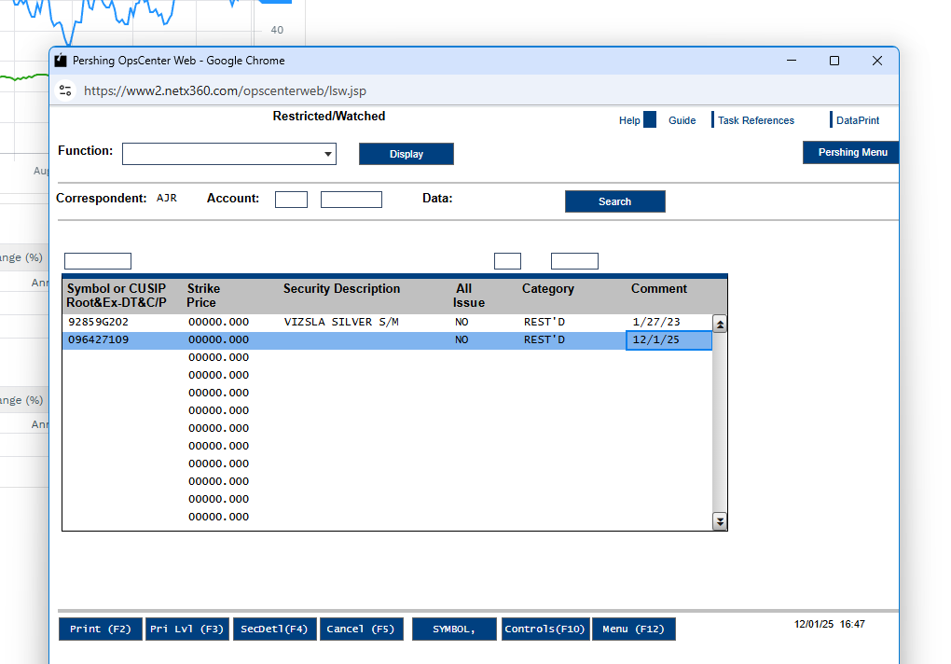

Hi Team,

No action required.

Hi Team,

Below update has been implemented.

Save email in: R:\1 - Compliance\Restricted Securities\RJL Trading Restricted List\2025

Log info in: R:\1 - Compliance\Restricted Securities\RJL Trading Restricted List

Compliance oversight manual

No Buys List
Tuesday, November 25, 2025
2:40 PM

Save in the the same folder in prohibited securities review

1RJ 022269 / Okeanos Venture Management LLC: REK.U / Rektron Group Inc. (QTY 75,000)... DRS transfer
Wednesday, November 26, 2025
11:00 AM
Isin: CA75941A1012
CUISP: 75941A101

DRS unrestricted, dtc eligible,confirmed that the restricted items were cleared
Fall under 0.5

Pershing has implemented the new policy that as of July 30, 2024, Pershing will no longer accept physical and electronic deposits of securities priced less than 50 cents per share (USD).

Check restriction: Searched CUSIP on RJ Net Report, shows VALIDATION_FAILED no result.
Current Price: 2.6 USD (not under 0.5 but less than 5, so low price security)
DTC eligible: 360+ - markets - security search - actions - details, no

Because the issuer is redeeming and cancelling the debenture, the client needs their shares registered directly with the transfer agent (via DRS) so the issuer/paying agent can verify ownership and process the redemption/settlement properly.

Security
Price of security
How client acquire
Account transfer is more versatile, tell them
we reviewed eberythimg is fine, but not dtc eloigible, so you might want to discuss it with operation team. Just let them know to get a possible way to deposit. Not redstricted , the secrity is tradingb at… price, just confirm it can be deposit as DRS

Wednesday, November 26, 2025
4:19 PM

Unsolicitated:
Canary
Rj net report
Factset: check what company sell (no canabais)

Titles
Thursday, November 27, 2025
9:30 AM

The title is not an approved title with RJLU, below is the list of RJLU approved titles:

- Financial Advisor
- Investment Advisor
- Investment Analyst
- Portfolio Manager
- Wealth Advisor Associate
- Financial Advisor Assistant

Oba and titles- titles- RJLU COMPLIANCE BULLETIN 25-01

Complaints 2
Thursday, November 27, 2025
11:05 AM

Thursday, November 27, 2025
11:33 AM

Hello Herman,
The security is not restricted slash prohibitedand is currently trading at dollar sign USD 2.60. However, Pershing shows the security as not DTC eligible, so you may want to check with the Operations team to confirm whether it can be deposited via account transfer.

If rjl website search :Validation failed, then
1. what sector cannabais otc,
- Chek that day's early morning restriction list.

Start wrap up branch inspection, has all branch inspection been completed
Document Integrity
Replace RJLU file 12.5

Thursday, November 27, 2025
1:33 PM

Prudent Process Questionnaire
Friday, November 28, 2025
1:01 PM

We plan to roll out the questionnaire to everyone, at the beginning of January next year. Access should be available before then.

Please let me know if you have any questions or concerns.

Despite our initial intention to roll out the Prudent Process Questionnaire in January 2026, due to an immense amount of interest we are looking to have this available sooner for everyone to use.

Once QA testing is completed, we should have this available to everyone.

Stay tuned.

Friday, November 28, 2025
2:11 PM

General:
For those emails that have been flagged due to triggering multiple rules, if neither rule is violated please clear the email in Issue Management with the following comment:

For all queries sent to Jocelyn Beckett (Calgary IAS), cc Calgary Supervision.
For all queries sent to Jocelyn De Jong (Edmonton IAS), cc Edmonton Supervision.
For all queries sent to Angela Lihnakis (Montreal IAS), cc Montreal Approval.
Hal & Nathan Biren have an agreement with RJ that all their clients have email authorization for order acceptance.
For all queries sent to Ottawa or Kanata, cc the BM and Nina Chatelain

False Positive - No rule violation:
No rule violation detected.

Blast Email - BE02:
True Violation:
Blast Email: Will Follow-up outside of Proofpoint.

False Positive - Approved research:
Closed: Blast email, includes research that is approved for general use. No issues.

False Positive - Approved marketing:
Closed: Blast email, includes marketing that is approved for general use. No issues.

False Positive - Non-marketing and non-research material:
Closed: Blast email that includes non-marketing and non-research material. No issues.

Order Acceptance - OA01:
True Violation - Client not notified:
No indication of client being involved in order process: Will Follow-up and Advise Offline.

True Violation - Order accepted via email:
Order seems to be accepted via email: Will Follow-up and Advise Offline.

False Positive - No issues with order acceptance:
Closed: No issues related to order acceptance.

False Positive - Non-RJL transaction:
Closed: Order related to non-RJ transaction. No issues.

Fair and Balanced Communication - FBC01:
True Violation:
Email contains exaggerated claims and/or unreasonable assurances regarding RJL products and services: Will Follow-up and Advise Offline.

False Positive - No exaggeration or false or misleading language:
Closed: No unreasonable or exaggerated statements identified.

False Positive - Language pertains to Non-RJL products/services:
Closed: Claims or statements unrelated to RJL products and services.

Information Security Labels (Outbound) - ISL1:
True Violation:
Email sent to unintended user(s): Will Follow-up and Advise Offline.

True Violation - RJL Research Package (Missing Disclaimer):
RJL Research Package sent to client(s) without Third Party Disclaimer: Will Follow-up and Advise Offline.

False Positive - RJL Research Package (Client Releasable):
Closed: Third Party Disclaimer included. No issues.

False Positive - Attachment blurb - RJL:
Closed: Not an ISL. Language pertains to 'section' in attachment that is for internal use. No issues.

False Positive - Attachment blurb - External:
Closed: Not an ISL. Pertains to wording in external un-related attachment.

False Positive - Email language:
Closed: Not an ISL. Pertains to wording in body of email. No issues.

False Positive - Email Signature - RJL
Closed: RJL email signature ISL. No issues.

False Positive - Email Signature - Non-RJL
Closed: Non-RJL email signature ISL. No issues.

False Positive - Email sent to intended recipient:
Closed: Email sent to and reviewed by intended user. No issues.

Anti-Bribery - AB01:
True violation:
Email contains indication of bribery or corruption: Will Follow-up and Advise Offline.

False Positive - No indication of bribery or corruption:
Closed: No indication of activity associate with bribery or corruption.

Canadian SIN w/ Additional PII *w/ Attachment:
True Violation:
Client SIN/PII Info enclosed in unprotected Email/Attachment: Will Follow-up and Advise Offline.

False Positive - RJL-related content (RJLU ONLY)
Closed: Emails contain RJL client-related PII information (unencrypted). Sent to RJL to escalate.

False Positive - No PII or SIN:
Closed: No SIN or other PII in the attachment or body of email.

False Positive - Protected using [Protect]:
Closed: Email that encloses client's SIN in body of email or attachment is protected.

False Positive - Protected using TLS System:
Closed: TLS system setup. Encryption not required.

False Positive - 5 PI Data Elements:
Closed: Includes one or more of the 5 PI data elements that are automatically blocked by Proofpoint.
full name, date of birth, SIN, account number, address

Customer Complaints External (PCG CASL and Complaints / RJLU ONLY) - CC01:
True Violation - HR/Legal Complaint:
Email contains indication of HR/Legal Complaint: Will Escalate to Manager.

True Violation - Securities Rules Complaint:
Email contains indication of Securities Rule Complaint: Will Escalate to DCO/DCO Delegate.

False Positive - No indication of customer complaint:
Closed: No indication of customer dissatisfaction identified.

Issue management - choose clear- paste comment - done

More- forward- to collin

If violation: More-retrive to inbox, leave red comment

All the website check excel sheet

Order acceptance: if only 1 email, we don’t need to review.

Email and social media monitoring - violation email correspondance- find format email
Then send it and cc BM

After FA send tracking number, what to do
Tuesday, December 2, 2025
11:57 AM

Revised Procedure — Physical Certificate Deposit
Process:
NetX360 → Service Center → Tracking Incoming Documents
Comment to Service Center:
Hi team,
The client has deposited a physical certificate and has already mailed the package.
Kindly facilitate processing once the package arrives.
Additional Steps:
- Select CUSIP
- Select Overnight

Rule 144 Legend Removal
Wednesday, December 3, 2025
1:50 PM

Thank you for the introduction, Zafar. I see from the information provided that that there are three different tranches of shares: 7,000 shares issued on January 2, 2024, 40,000 shares issued on May 5, 2025, and 10,000 shares with no documentation indicating the issue date. I note that the physical stock certificates are all dated August 19, 2025. In order to assess the available exemptions to facilitate a legend removal and/or share transfer, please provide the original issue date of the tranche of 10,000 shares. In addition, I need to know whether Mr. Morton is an affiliate of Yangarra. Specifically, I need to know whether he is a director, officer or owner of 10% or more of any Yangarra class of voting capital stock. Also, it would be helpful to understand if Mr. Morton is intending to sell these shares, or if he is only trying to remove the legend to facilitate depositing the shares in a brokerage account.

Under U.S. law, Rule 144 promulgated under the Securities Act of 1933 only permits legend removal that is not in connection with a sale or transfer of the subject securities if the shares have been owned for at least 12 months and the holder is not an affiliate. In this regard, the tranche of 7,000 shares issued on January 2, 2024 have been held for at least 12 months and we could issue an opinion to remove the legend if Mr. Mortan is not an affiliate of Yangarra. However, the tranche of 40,000 shares issued on May 5, 2025 have not been held for at least 12 months and therefore would not be eligible for legend removal under Rule 144.

Section 4(a)(7) of the Securities Act of 1933 provides for a statutory exemption for the sale of shares that have been held for at least 90 days, subject to certain public information about the company being available and only if the purchasers qualify as accredited investors as defined in Rule 501 of the Securities Act of 1933. As a public reporting company in Canada, Yangarra satisfies the public information requirements of Section 4(a)(7), so we could issue an opinion to remove the legend with respect to the 40,000 shares in connection with the sale of the shares to an accredited investor. Such opinion would only apply to a specific sale to a specific purchaser whose accredited status was confirmed, and the purchaser would receive the shares subject to the same restrictive legend.

Treatment of the tranche of 10,000 shares will depend on the original issue date and whether the Rule 144 or Section 4(a)(7) exemptions are available.

Thursday, December 4, 2025
12:39 PM

RJLU- Branch Inspection RJLU- Branch Review Document -

Branch Inspection Report
Monday, December 8, 2025
6:37 PM

R:\Branch Review - RJLU\Branch Review Documentation\

Branch Inspection 2025 Report - TEMPLATE

Aa- Branch review checklist -

Once done, if any questions

Inspection Tracking folder, put all info in it even don't have issue

Use example of Marc Latta

Jacqulie ramer

Montreal IAS

FA Questionare: check smartsheet

Social media: go back to questionnaire asnwer sheet find related questions
Retail communication: I can't do it

R:\Branch Review - RJLU\Branch Review Documentation\Toronto- 40 King St West IAS
R:\Branch Review - RJLU\AA-Branch Review Checklist and Tracking\Inspection Tracking\Branch Inspection Tracking 2025
R:\Branch Review - RJLU\Branch Review Documentation\Toronto- 40 King St West IAS\2025 Onsite

Reciew date : upfront date
Date review summary: today
Change fa NAME, BLACK
Check Kevin Janjua example.

- Word, FA questionnaire
- Retail communication

FINRA/SPIC

Update 2 trackers:
Inspecyion trackineg
OSJ Branch

Save disclosure email in the folder
<<2025 Branch Inspection Report - Dembla FINAL.pdf>>

Thursday, December 11, 2025
11:18 AM

PACE- FLAG ACCOUNT

Pace block after legend removal

The PACE was placed due to a legend removal. Compliance has no concerns removing the PACE BLOCK for ACH withdraw. Please kindly reinstate the PACE Block back to the account once the transaction is complete.

COR

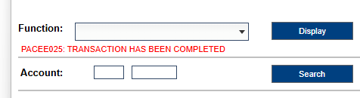

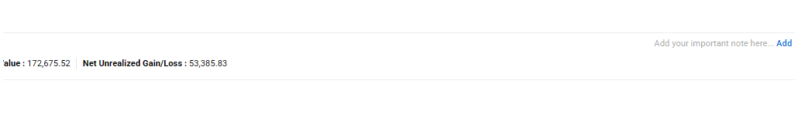

It looks like yesterday's dailies might have been overwritten when today's file was saved.

What decide solicited or unsoliciated
Friday, December 12, 2025
1:22 PM

If its low price secuity or not blue sky compliant, can't be solicitaed

Tuesday, December 16, 2025
10:04 AM

1-complaince complaints and disclousure

PTO Tracker
Friday, December 19, 2025
5:13 PM

PTO:
September 8,9,10
November 18
December 15, 23, 24,29,30,31

Sick Day:
December 22

Calendar: https://calendar.smartsheet.com/calendars/published/9c0508b0-21bf-4dfd-9965-5d91bd65c251

Click Browse

Use conditional formatting to change category's color

File-share-copylink

Hello,

The PTO request tracker for RJLU Supervision is now ready. Please bookmark the following links for your convenience:

Submit a PTO request (login required):
https://app.smartsheet.com/b/form/019b04e620307468be8c96477d074f86
View the PTO calendar (public link, no login required):
https://calendar.smartsheet.com/calendars/published/9c0508b0-21bf-4dfd-9965-5d91bd65c251
Manage the tracker and view stats (shared access only):
https://app.smartsheet.com/sheets/hxP6Mq5699xGXHcjGX2C8wrgwq7v5C83hvwFphC1

Thank you, and please reach out if you have any questions.

Process of Legend Removal
Monday, January 5, 2026
4:55 PM

This security is not classified as a low priced security; therefore, a DRS transfer is permissible to deposit this security.

The legend removal can either be processed outside of RJLU if the security is not been deposited in client account, or through RJLU/Pershing, LLC once the security has been deposited at client's RJLU account.

Please be advised that the legend removal under Rule 904 (U.S. citizen owns the stock of a Canadian company, which can only be sold in Canada. The stock cannot be sold again to a U.S. citizen or entity) may be considered after the applicable one-year holding period has elapsed, from the time that the client acquired the security.

For a Rule 904 (Regulation S) legend removal request through RJLU, the client is required to provide the following documentation:
- Stock Power
- Seller’s Representation Letter
- Seller’s Declaration Letter
- Broker Letter

Please let me know if you have any additional questions or concerns.

Account transfer form

For a legend removal request processed through RJLU, the documentation is generally required once per legend removal request, not per individual DRS, provided that:
- The request covers the total amount of shares being deposited and processed at the same time, and
- All shares are of the same issuer, subject to the same exemption (e.g., Rule 904), and
- There are no differences in issue dates, holding periods, or affiliate status across the shares.
If the shares involve multiple tranches with different issue dates, different exemptions, or are processed at different times, separate documentation may be required for each tranche or request.

Also, just a correction from our previous email, please note that the Stock Power is not required for DRS transfer.

Check dailies RSK, legend removal is completed, we going to tracker to see if we charged before
Same client, new security, still need to charge fee
To pace block, block all cash movement
Operations knows check pace block everytime
Everytime we do legend removal, we do pace block
Same person to pace block and remove.

Charge the fee, place paceblock, then leave a note on netx

Only restrited do legend removal, first client or first company, do the charge fee

Tuesday, January 6, 2026
11:58 AM

Website: Compliance frequently asked quetsion
Dealing with US resdient

LPSQ - Marie Ann Poppy
Tuesday, January 6, 2026
12:35 PM

Since July 30, 2024, Pershing does not accept:
• Securities priced below $0.50 USD (current is 2 CAD)
• Securities listed on OTC Grey Market or Expert Market, including “No Information” securities (client is CHICAGO IL, canary:yes)
• Securities designated as Caveat Emptor (search on OTC Markets website )

Required documents:
1. Scanned front and back of the physical certificate (only front)
2. Completed Low Price Security Questionnaire (LPSQ)
3. Electronic signature summary, if applicable
4. Supporting documents for share acquisition

Graphene Manufacturing Group Ltd, a clean-technology company, engages in the manufacture of graphene powder and energy saving and energy storage solutions enabled by graphene in Australia.

Restricted:
Shows no restrictions, warrant not on the list
The shares are unrestricted, the physical certificate has legend

  - How client acquire the shares
These were received from her husband upon his passing. Bryan had the shares deposited into his RJLU account in 2024 and upon his passing in 2025, we went through the process of transitioning the stock to be in the name of her Trust.
The original account of her late husband is 1RJ019885 All documentation for the reception of the stock are on file there.
I found document on NetX: 09/09/2025
Original stock certificate for 100000 common shares tock certificate
Original certificate for warrants to purchase 50000 Warrant certificate
2024/01/25 received
2025/09/09 transferred

  - Whether this share should be issued legend free
On physical certificate, it has legend.

BM is Darrin

LPSQ - Marie Ann Poppy Trust 1RJ024083 - Graphene Manufacturing Group Ltd - 100,000 common shares + 50,000 warrants

Hello Darrin,

Please find attached the LPSQ and related supporting document for your review.

Client Marie Ann Poppy, 1RJ024083, requested to deposit 100,000 common shares + 50,000 warrants of Graphene Manufacturing Group Ltd, which is currently trading at $2.61 CAD.

The shares were originally deposited into client's late husband's RJLU account in 2024 and were transferred out in 2025. The original account of her late husband is 1RJ019885 All documentation for the reception of the stock are on file there.

Compliance has no further concerns regarding this legend free warrant deposit.

The security is not restricted/prohibited by the security review group from RJF.

Kindly review and provide us with a signed copy of the LPSQ, if approved on your end.

Hello Steven,

The LPSQ has been reviewed and approved by Branch Manager. We are good to proceed with the deposit.

Please ask your client to complete the following instructions to deposit the 100,000 common shares + 50,000 warrants of Graphene Manufacturing Group Ltd:

The client is to send to Pershing via FEDEX/UPS all the following original documents:

  - Original Stock Certificate (please have the client’s RJLU account number in the top right-hand side of the certificate)
  - Stock Powers – signed by the registered holder with a wet signature.

Pershing’s address to receive those documents is:

Attn: Securities Receive Department
PERSHING LLC
1 PERSHING PLAZA
7TH FLOOR CUSTODY GROUP
JERSEY CITY NJ 07399

Kindly ensure to provide me with the courier’s tracking number.

Email about Website update
Wednesday, January 7, 2026
1:45 PM

Website Disclosure Update

Just a friendly reminder that the required RJLU FINRA/SIPC disclosure and BrokerCheck link are not currently visible on your website.

When you have a moment, please work with the Corporate Communications team to update the disclosure section so the required information is clearly displayed.

For your convenience, website updates can be requested through the appropriate ServiceNow catalogue: RJL Advisor / Branch Website Change Request

Please let me know if you have any questions or need assistance.

HRS Reporting
Thursday, January 8, 2026
2:42 PM

There are no restricted securities escalated for deposit/transfer in during Q1 – October 1, 2025-December 31, 2025

Hi James,

Thanks for confirming,

After discussing with Harris, I can confirm that we don’t have any case to report for the previous quarter. Since both securities are transferred from client existing holdings. They didn’t go through the exception process to be transferred in.

Friday, January 9, 2026
10:17 AM

US resident has ti be registered in the US
IF a security is unregistered, when US resident require it, it requires restriction
Restriction period is over, sell this outside US

remocing restriction is removing legend
Largest instutuion buy stock, may me able to sell stock by having legend removed through call rule 144A.

Friday, January 9, 2026
10:41 AM

Private purchase
Schedule B
Hondo is qualified instituational buyer

Each DRS

Email Monitoring Comments
Friday, January 9, 2026
2:14 PM

General:
For those emails that have been flagged due to triggering multiple rules, if neither rule is violated please clear the email in Issue Management with the following comment:

For all queries sent to Jocelyn Beckett (Calgary IAS), cc Calgary Supervision.
For all queries sent to Jocelyn De Jong (Edmonton IAS), cc Edmonton Supervision.
For all queries sent to Angela Lihnakis (Montreal IAS), cc Montreal Approval.
Hal & Nathan Biren have an agreement with RJ that all their clients have email authorization for order acceptance.
For all queries sent to Ottawa or Kanata, cc the BM and Nina Chatelain

False Positive - No rule violation:
No rule violation detected.

Blast Email - BE02:
True Violation:
Blast Email: Will Follow-up outside of Proofpoint.

False Positive - Approved research:
Closed: Blast email, includes research that is approved for general use. No issues.

False Positive - Approved marketing:
Closed: Blast email, includes marketing that is approved for general use. No issues.

False Positive - Non-marketing and non-research material:
Closed: Blast email that includes non-marketing and non-research material. No issues.

Order Acceptance - OA01: if send to Pershing to buy then it's ok
True Violation - Client not notified:
No indication of client being involved in order process: Will Follow-up and Advise Offline.

True Violation - Order accepted via email:
Order seems to be accepted via email: Will Follow-up and Advise Offline.

False Positive - No issues with order acceptance:

Closed: No issues related to order acceptance. \
The activity reviewed pertains to an employee’s personal transaction, not a client transaction.

False Positive - Non-RJL transaction:
Closed: Order related to non-RJ transaction. No issues.

Fair and Balanced Communication - FBC01:
True Violation:
Email contains exaggerated claims and/or unreasonable assurances regarding RJL products and services: Will Follow-up and Advise Offline.

False Positive - No exaggeration or false or misleading language:
Closed: No unreasonable or exaggerated statements identified.

False Positive - Language pertains to Non-RJL products/services:
Closed: Claims or statements unrelated to RJL products and services.

Information Security Labels (Outbound) - ISL1:
True Violation:
Email sent to unintended user(s): Will Follow-up and Advise Offline.

True Violation - RJL Research Package (Missing Disclaimer):
RJL Research Package sent to client(s) without Third Party Disclaimer: Will Follow-up and Advise Offline.

False Positive - RJL Research Package (Client Releasable):
Closed: Third Party Disclaimer included. No issues.

False Positive - Attachment blurb - RJL:
Closed: Not an ISL. Language pertains to 'section' in attachment that is for internal use. No issues.

False Positive - Attachment blurb - External:
Closed: Not an ISL. Pertains to wording in external un-related attachment.

False Positive - Email language:
Closed: Not an ISL. Pertains to wording in body of email. No issues.

False Positive - Email Signature - RJL
Closed: RJL email signature ISL. No issues.

False Positive - Email Signature - Non-RJL
Closed: Non-RJL email signature ISL. No issues.

False Positive - Email sent to intended recipient:
Closed: Email sent to and reviewed by intended user. No issues.

Anti-Bribery - AB01:
True violation:
Email contains indication of bribery or corruption: Will Follow-up and Advise Offline.

False Positive - No indication of bribery or corruption:
Closed: No indication of activity associate with bribery or corruption.

Canadian SIN w/ Additional PII *w/ Attachment:
True Violation
:
Client SIN/PII Info enclosed in unprotected Email/Attachment: Will Follow-up and Advise Offline.

False Positive - RJL-related content (RJLU ONLY)
Closed: Emails contain RJL client-related PII information (unencrypted). Sent to RJL to escalate.

False Positive - No PII or SIN:

False Positive - Protected using [Protect]:

Closed: Email that encloses client's SIN in body of email or attachment is protected.

False Positive - Protected using TLS System:
Closed: TLS system setup. Encryption not required.

False Positive - 5 PI Data Elements:
Closed: Includes one or more of the 5 PI data elements that are automatically blocked by Proofpoint.

(SIN number, SSN, credit card number, passport number, driver license number)
Number will be provided

If the Proofpoint Encryption Premium Add-in for Outlook is installed on your work computer:
Click the Send Secure or Proofpoint Standard Encryption button (depending on which
version of Outlook you have) instead of the regular Send button.
This method does not require you to include the word [protect] in the Subject line, but it will
automatically add [Encrypted / Chiffrement] in the Subject line.

Customer Complaints External (PCG CASL and Complaints / RJLU ONLY) - CC01:
True Violation - HR/Legal Complaint:
Email contains indication of HR/Legal Complaint: Will Escalate to Manager.

True Violation - Securities Rules Complaint:
Email contains indication of Securities Rule Complaint: Will Escalate to DCO/DCO Delegate.

False Positive - No indication of customer complaint:
Closed: No SIN or other PII in the attachment or body of email.
Closed: No client SIN or other PII found in the attachment or email body.

Closed: No indication of customer dissatisfaction identified.

If violation, retrieve to inbox,
True Violation:
Client SIN/PII Info enclosed in unprotected Email/Attachment: Will Follow-up and Advise Offline.
Client SIN/PII Info enclosed in unprotected Email/Attachment: Will Follow-up and Advise Offline.
If it’s complaints, send to Harris

R:\1 - Compliance\Email and Social Media Monitoring\Violation Email Correspondence\2026
If FA replied, save email to the folder
Send email to Privacy if there's a issue
<<Emails Flagged for the Canadian SIN & PII rule .msg>><<Email Review - Unencrypted Email - Michael Low.msg>>

Monday, January 12, 2026
1:34 PM

Generate points
Tier level 0-3 max allocation 50 dollars 25-5000 equal amount, 1st points, 1 dollar 50 points
2 weeks limit
3 days tier 1
7 days tier 2
50 dollars,
Small amounts of input, even in the middle
How many
50 dollars give at will 5000 points per project
1
2 1-5 hours

LPSQ - Silver Wings
Tuesday, January 13, 2026
11:33 AM

Reverse takeovers
Carcetti acquire 100% interest in the Hemlo

client wants to process electronically
Unrestricted, and not low priced security
Canadian security, not trading in the US, they won't be able to receive it
Pershing doesn't know this secuirty

Then receive it as foreign security
Hariis sign foreign receive form

- How client acquire the shares
- Whether this share should be issued legend free or unrestricted

Find out Someone removed the legend and why

Find why the shares are restricted at the beginning. Because client is US person
Transfer agent removed the shares. Do we have to en force the legend on the shares.

Hondo
Thursday, January 15, 2026
10:55 AM

904 Letter
Thursday, January 15, 2026
11:00 AM

Compliance Oversight folder - 904 - Restricted Shares
Find a template

RJLU account in different state questions
Friday, January 16, 2026
11:11 AM

Broker: commision account
Investment Advisor: P74. p75
Check if they registered as broker

Next Year Plan
Monday, January 19, 2026
3:37 PM

Best execution: set template for 5% deviation
Document Integrity: Find what FA has issue that not been recorded

Tuesday, January 20, 2026
2:24 PM

We get that inquery from Bradley Clark in IAS Victoria, brad ask what type of account he can open before get get Series 63 completed?
Can we forward it to you to answer?
If you prefer, we can provide answer with

Only FA can see record, Fa can douwnload and share it with

We received an inquiry from Bradley Clark at IAS Victoria. Brad is asking what types of accounts he is able to open before completing his Series 63.
Could we forward this question to you to respond directly?
Or if you prefer, we can provide a response to him instead.

Prudent Process
Tuesday, January 20, 2026
2:38 PM

As shown in the introduction video, if your assistant is helping with transcribing meeting notes, you can download the records and share the file with your assistant. Feel free to check out the introduction video on the Prudent Process page for more details.

Click SETTING
Restrict

click Questionnaire reponse sheet- click forms - manage forms - click 3 dots

Copy all the information from prudent process questtionnare: including hiding information, eg. others

RJLU Registration
Wednesday, January 21, 2026
3:35 PM

We have an advisor want join rjlu, could you help him to start
Steven ,arcus

Hope you are doing well.

We have an advisor who would like to join RJLU. Could you please help him get started?

Thank you very much for your assistance.

Large Options OCC report
Wednesday, January 21, 2026
4:35 PM

R:\Compliance Oversight\Large Options Positions Transmitted to OCC

LPSQ - Okeanos Venture Management LLC: REK.U / Rektron Group Inc. (QTY 75,000) 1RJ 022269
Friday, January 23, 2026
1:34 PM

Manual DRS Transfer

Since REK.U / Rektron Group Inc. is a low priced security, please have the client fill out and complete the attached the LPSQ form and submit back to us for review. Please also provide us with supporting documentation on how the security was acquired by the client.
Rektron Group Inc., through its subsidiaries, trades in ferrous and nonferrous metals, crude oil, and refined oil products worldwide. The company offers crude oil; petroleum products, such as gasoline, diesel fuel, heating oil, and lubricants; and gas products that includes LNG, biofuels, and pipeline gas.

Restricted to RJF:
Validation failed, so I checked today's full prohibited securities list

  - How client acquire the shares
The client (Okeanos Venture Management LLC) acquired the 75,000 common shares of Rektron Group Inc. as consideration for the redemption and cancellation of a CDN $250,000 debenture previously issued by Stellar Spirits and Wines Inc.

  - Whether this share should be issued legend free or unrestricted

Hello

Please find attached the LPSQ and related supporting document for your review.

Client Marie Ann Poppy, 1RJ024083, requested to deposit 100,000 common shares + 50,000 warrants of Graphene Manufacturing Group Ltd, which is currently trading at $2.61 CAD.

The shares were originally deposited into client's late husband's RJLU account in 2024 and were transferred out in 2025. The original account of her late husband is 1RJ019885 All documentation for the reception of the stock are on file there.

Compliance has no further concerns regarding this legend free warrant deposit.

The security is not restricted/prohibited by the security review group from RJF.

Kindly review and provide us with a signed copy of the LPSQ, if approved on your end.

LPSQ - Western Alaska Copper & Gold Company- P74008403
Friday, January 23, 2026
4:06 PM

No Fa signature
No number of shares
No legend on the back of the physical certificate
Agreement shows alteration

Restricted to RJF: no restriction
  - Client answered restrictive legend

How client acquire the shares:
The client acquired these shares by participating in the company’s 2017 stock purchase through a subscription agreement.
The letter confirms that:
  - A subscription agreement was executed in 2017.
  - The client contributed funds as part of the December 2017 capital raise from existing shareholders (approximately $1.3 million raised in total).
  - In return, the client received a stock certificate for shares in Western Alaska Copper & Gold Co.

Firstly, please confirm that number of shares The client requests to deposit. From the providing document, there're 2 shares from the physical certificate and 180 proportional shares from the DRS statement.

However, the DRS statement shows restriction. Although Operations may be able to process the request, there is a risk that Pershing may reject the deposit.
At this stage, there are two possible options:
  - The client contacts the transfer agent to convert and reissue the physical certificate for 180 shares. We then process the deposit of 2 shares + 180 shares together.
  - We processes the physical certificate (2 shares) first and waiting for reissued physical certificate (180 shares) to process later.

  - Split processing
    - Compliance processes the physical certificate (2 shares); and
    - Operations processes the restricted securities DRS transfer (180 shares).
  - Reissue via transfer agent
    - The client contacts the transfer agent to convert and reissue the securities into a physical certificate;
    - We then process the deposit of 2 shares + 180 shares together.
We can proceed either separately or simultaneously, depending on the preferred approach

Please fill out the number of shares, current price per share and Financial Advisor Signature on LPSQ.

If DRS shows legend, then it only can do by transfer to physical certificate.

Hi Carol,

As discussed over the phone, please first confirm the number of shares the client is requesting to deposit. Based on the documents provided, there are 2 shares from the physical certificate and 180 proportional shares from the DRS statement.

However, the DRS statement shows that the shares are restricted. Although Operations may be able to process the request, there is a risk that Pershing may reject the deposit.

At this stage, there are two options:
  - The client contacts the transfer agent to convert and reissue a physical certificate for the 180 shares. We will then process the deposit of 2 shares and 180 shares together.
  - We process the physical certificate (2 shares) first and wait for the reissued physical certificate (180 shares) to process the remaining shares later.

Please let us know how you would like to proceed.

In addition, please complete the LPSQ with the number of shares, current price per share, and the Financial Advisor’s signature.

Legend removal
Monday, January 26, 2026
11:47 AM

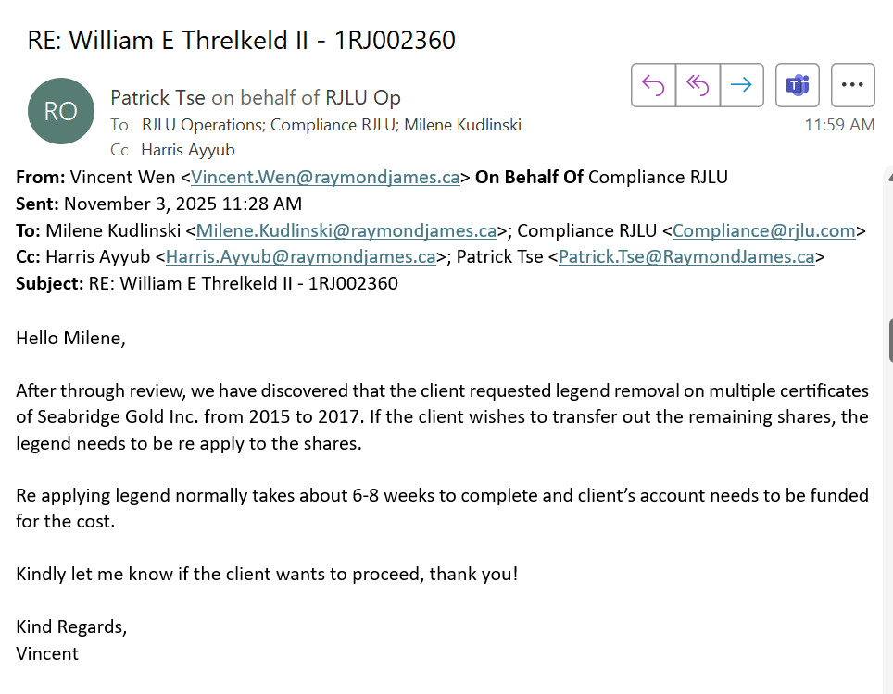

From <https://teams.microsoft.com/v2/>

Go to Rjlu folder, supervision-low price larage ahre dep log
Check how many shares was removed the legend
Google, the company, investing.com, check split ratio to see if there's any stock split
if there is any stock split, the share amount will change, for example. client removed the legend for 100 shares in 2020, then 2021 there is a 1-5 stock split, then in 2021, client holds 500 shares. now at 2025, if we want to reapply the legend back on the shares, we should apply legend for 500 shares.
To calculate how many was removed and how many shares need to be relegended
1. has the issuer changed its name since 2017.and what is the current name. then, 2. is there any stock split
Go to netx, check do we still have this position in the account?
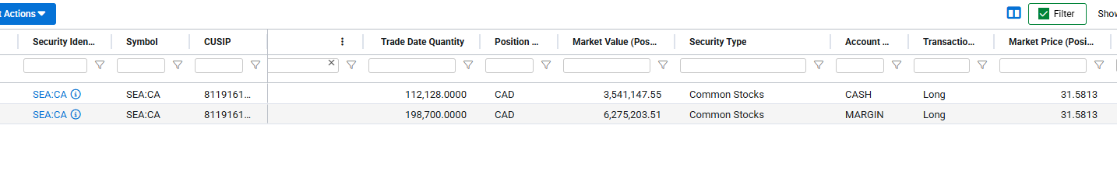

export all the transactions for the past 5 years, and check how much were brought?
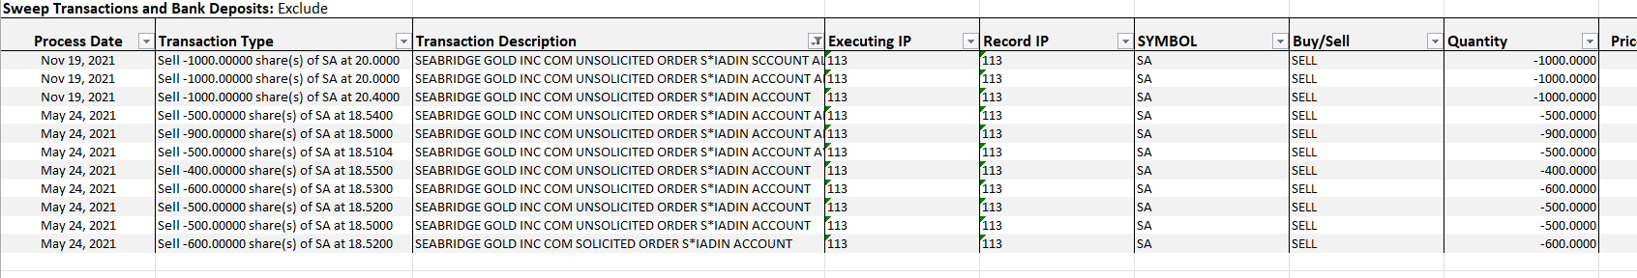

check the account statement
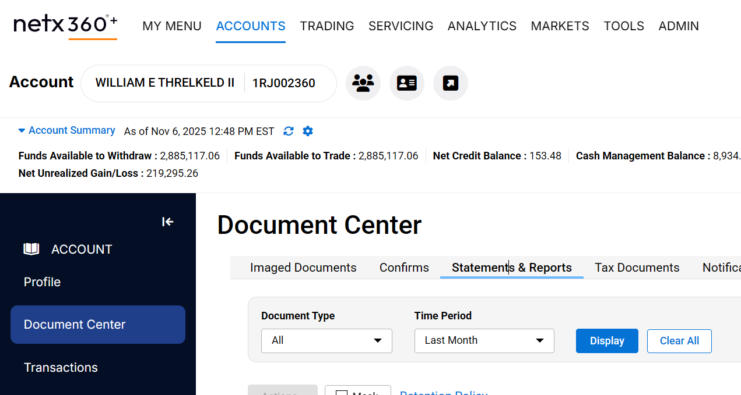

After legend removal, must pace block

For accounts 1RJ007005 and 1RJ019802, please note that we plan to reapply the legend. Could you please hold off on the process for now?

Reapplying Legend to Securities

Hi There,

Please advise what process is for reapplying the legend on BQE and GRA positions to facilitate transfer out in kind. Thank you.Yuan

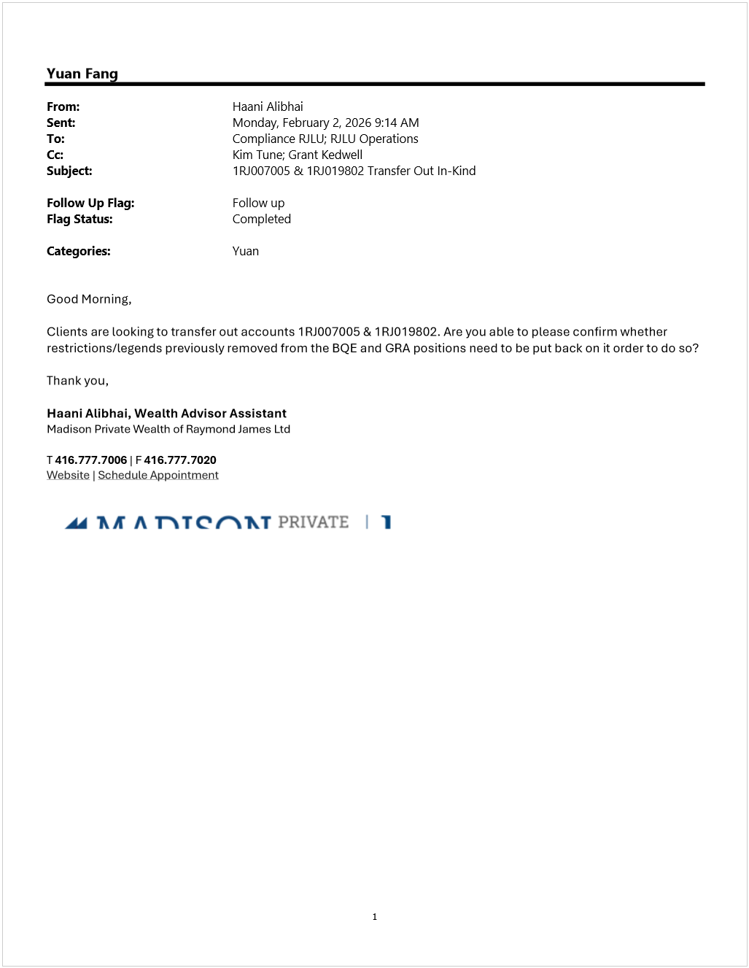

RE_ Restricted stock - Legend Removal SCOTT HAND _ 1RJ011775
Monday, January 26, 2026
4:55 PM

Go to NETX - ACCOUNTS - work status check all pending process- audit trail

If it's legend removal , go to items for attention

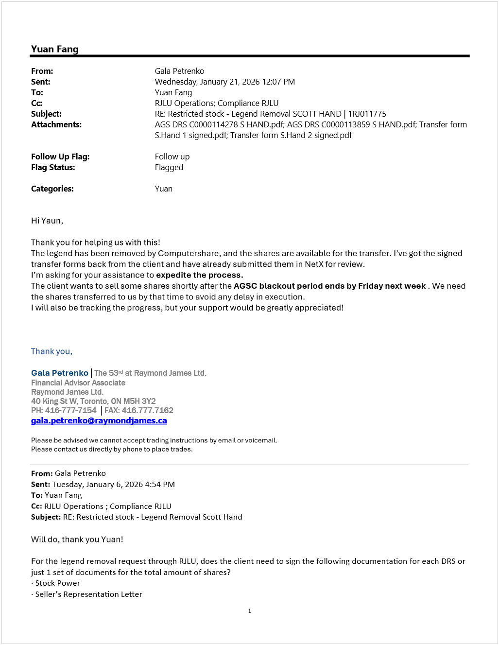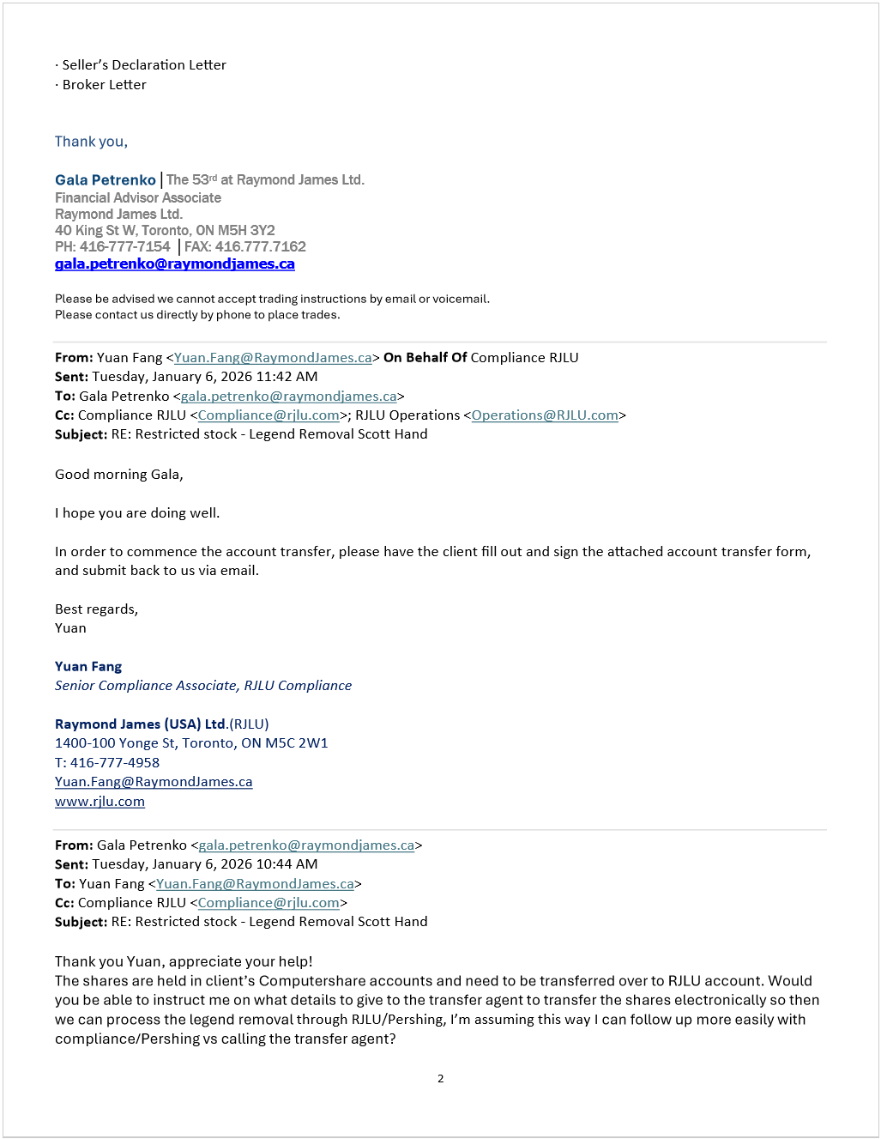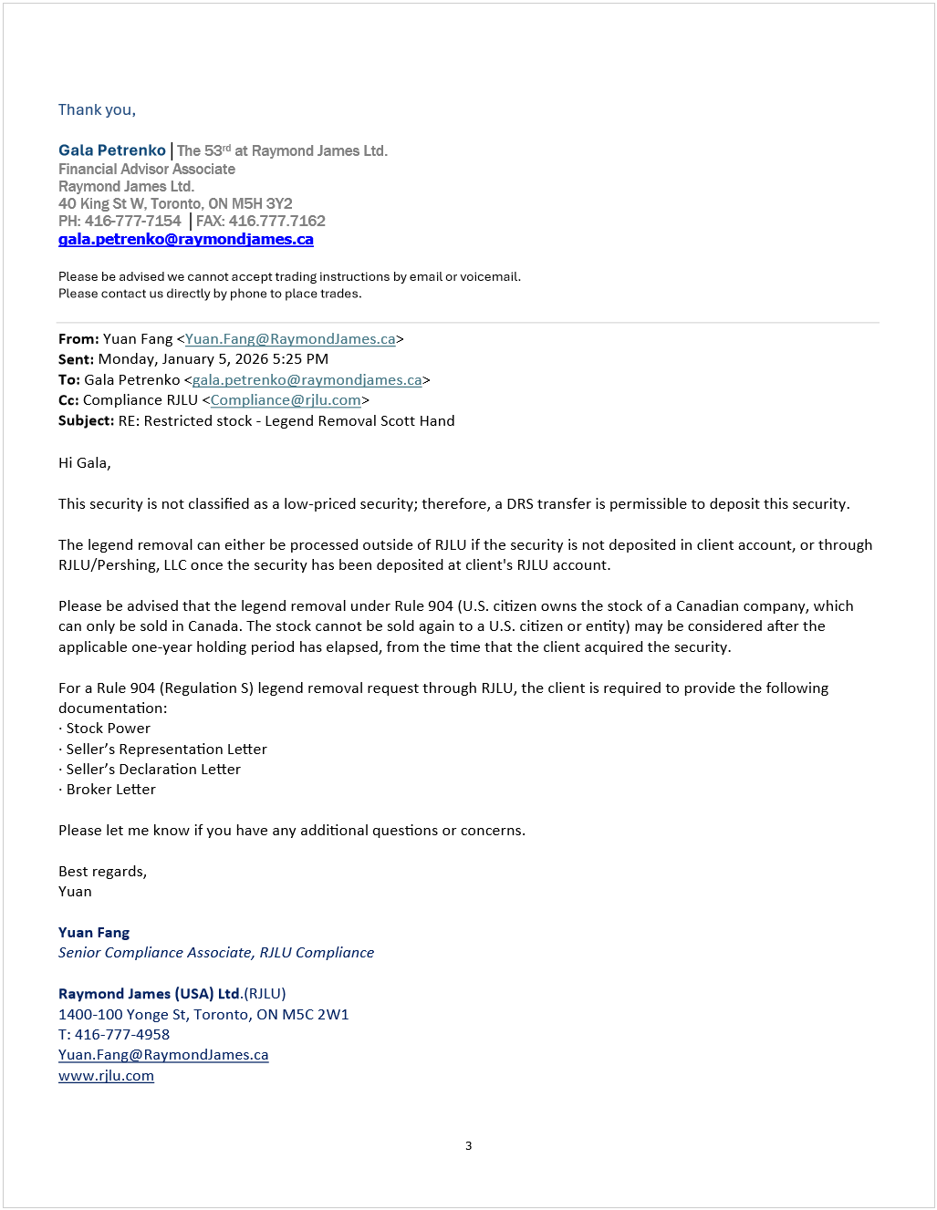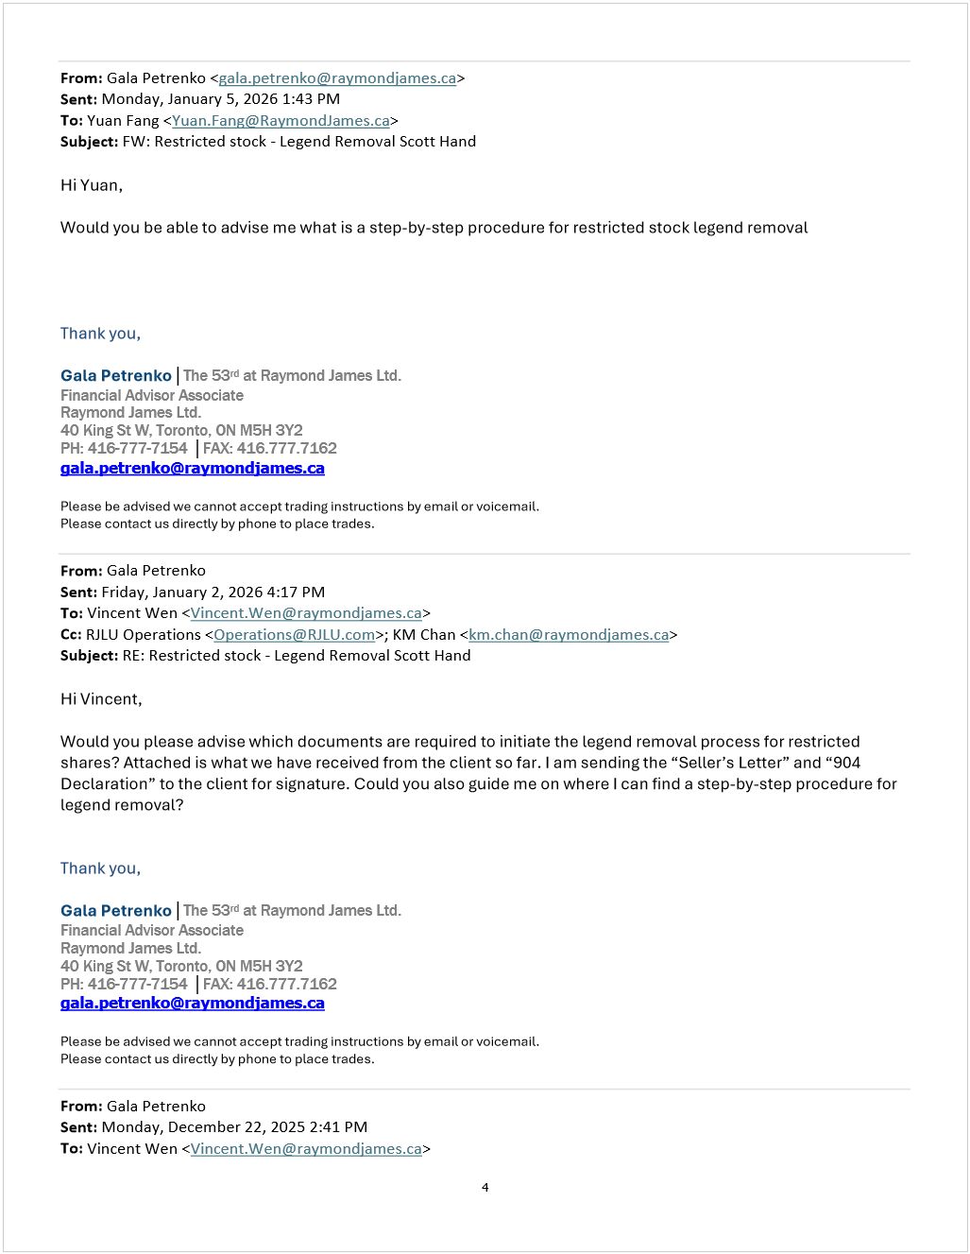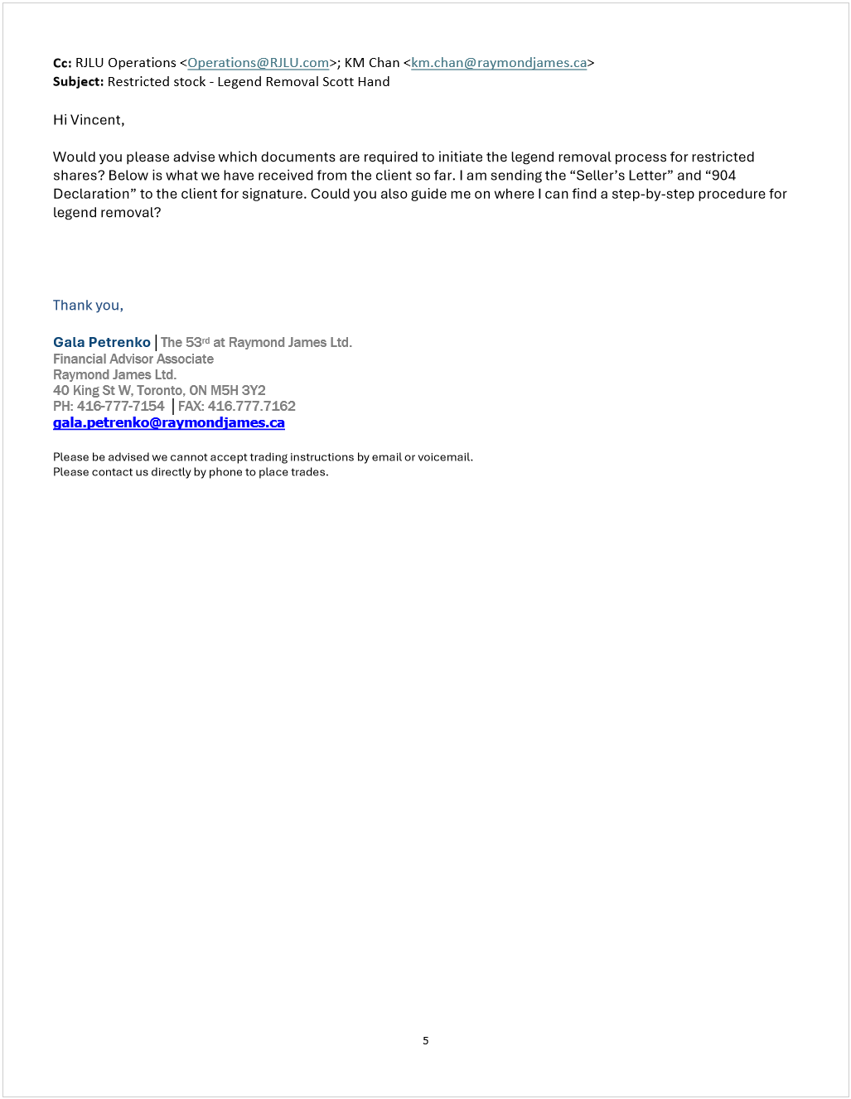

Supervision Data
Tuesday, January 27, 2026
9:45 AM

1-compliance, prudent process

Netx report name: RJLU Supervision - New Account, RJLU Supervision- Trade data

Cyopy and paste data from netx to format spreadsheet
Activity: only select buy and sell

IP name: remove firm accounts

Check accounts in US specific State
Wednesday, January 28, 2026
2:19 PM

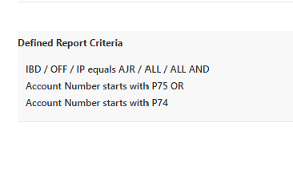

904 broker's letter
Thursday, January 29, 2026
1:39 PM

Compliance oversight - 904 - wes korhanan

Find 904

change date, number of shares

Document center- safe keeping(pershing is safekeeping the document), find the physical certificate that shows same shares

Also check pending paper

Change BM's name

Print, then BM sign it

Folder: #RJLU information - Pershing shipping info

Charge code: U8686

Expediate legend removal process to Pershing
Thursday, January 29, 2026
2:39 PM

Control + tab: people's information

<<Legend Removal Expediting Request.msg>>

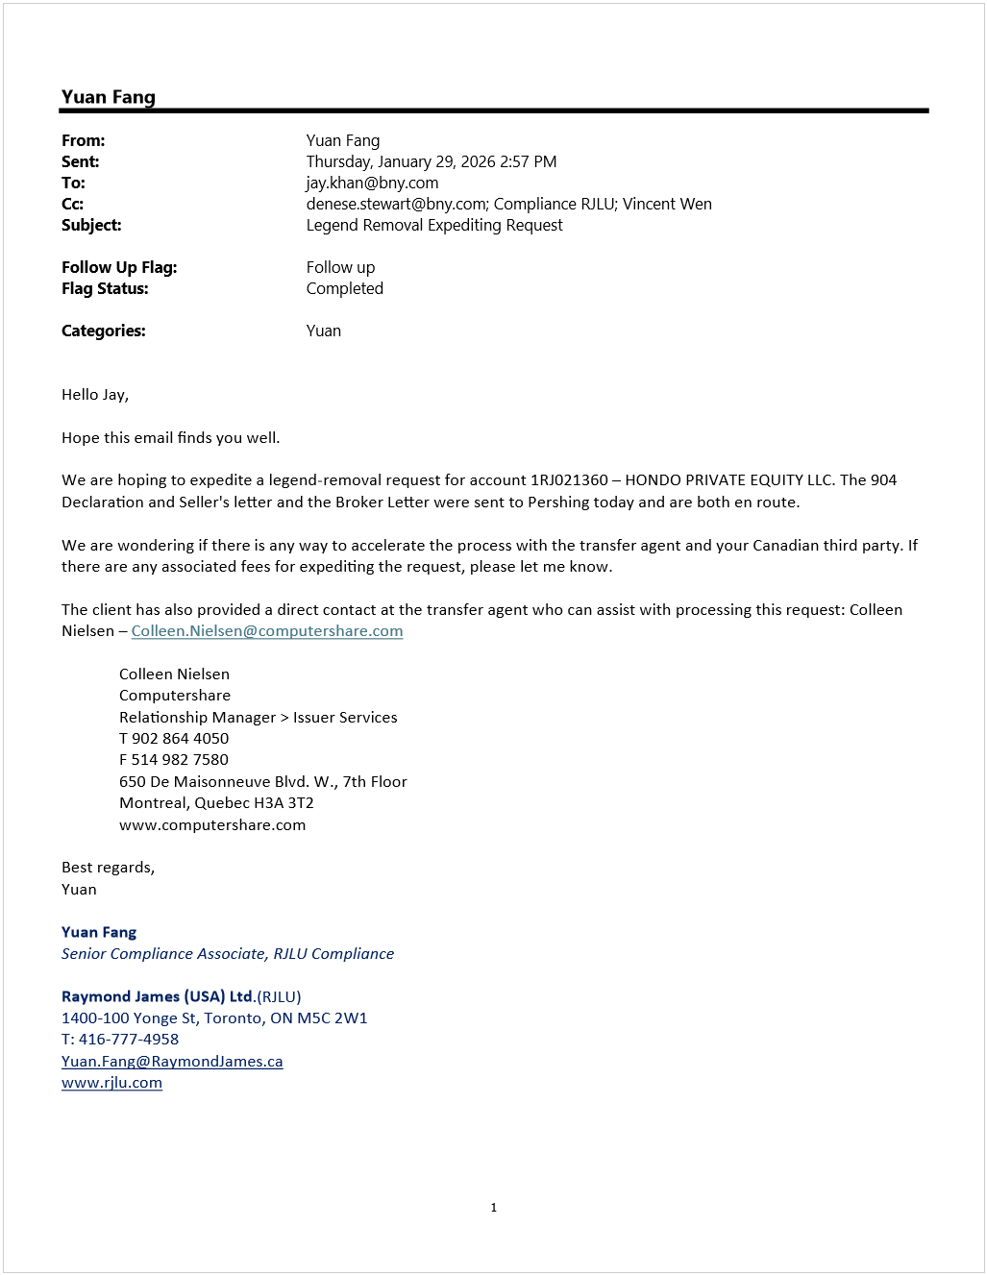

Friday, January 30, 2026
10:38 AM

The link is not on NetX360.
Please first click on the RJLU Prudent Process SharePoint page shown below, then select the Prudent Process Dashboard. You will be redirected to Smartsheet. After signing in, you will be able to see all account numbers along with the corresponding questionnaire links.
For more details, please feel free to review the introduction video available on the Prudent Process page.
Please let me know if you have any questions.

Monday, February 2, 2026
9:18 AM

Referral Agreement
Monday, February 2, 2026
1:28 PM

1-compliance- FA Reeferral Program
people in canada wants to to US Business, then need agrrement to deciside commission.
RJL adfivsor is refeered to RJLU
FINRA reguration to track every year, is there're any changes

Then BM sign agreemrnt, then send to Steven Marcus

1-operations- referal agreement- referral program use their log to compare with our, so need to confirm
Need to check "cxl agreement"

Save unsignd agreement and BM signed agreemrnt both in 1-compliance- FA Reeferral Program-1.referre's annual compliance report

Check 1 times per month, start of month, check operation side

April

RJLU Annual Referral Compliance Report 2026 - Kalee Boisvert & Greg David Kanary - BM Signed

Check "month" "F" as standard

RS Legend Removal Fee $350
Tuesday, February 3, 2026
4:10 PM

1.Charge Review Fee
  - NETX -> open client’s account -> On the top choose: servicing -> asset movement -> journals + between accounts, continue -> receiving account = sundry account: AJR890698 -> continue -> request reason: fee -> admin fee -> disclosed to the client? Yes -> all comments: DD – Review Fee – (stock name) -> change amount to $350.00 CASH (move qty/amt)-> review before sending -> paste the comment again -> send
  - Update both spreadsheets (daily trade report and master spreadsheet)

  - After charging review fee, put a PACE block on the account to prevent the security from being transferred out.

2.Flag an Account (PACE block)
  - Click Service & Operations > OpsCenter.
  - Click PACE - Pershing Automated Cash Exchange.
  - If you want to search, In the Account Information section, click FLAG-Account Flags.
  - In the Account field, type an account
  - Click Add.
  - In the From Account box, type the account number.
  - In the Flag box, select the block
  - In the Reason field, type reason code: COR
  - Press Enter. The Block or Hold will be processed.
  - 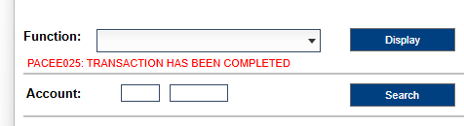

  - Add note on Netx
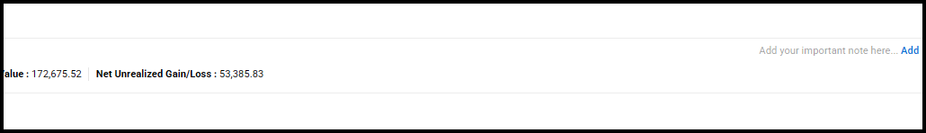

e.g.
VW on 07/16/24 - Legend removal of *** shares of ***., under Rule 904. Stock cannot be traded on any US market and cannot knowingly be sold to any US resident. Stock cannot be transferred out of account without BM/Compliance approval.

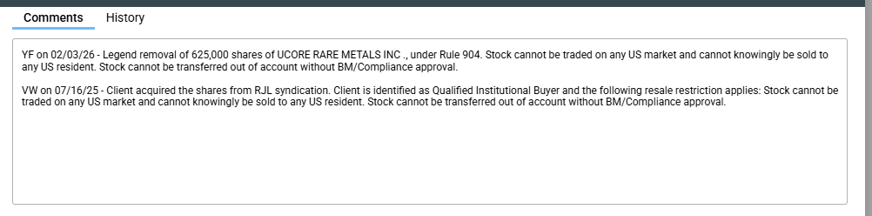

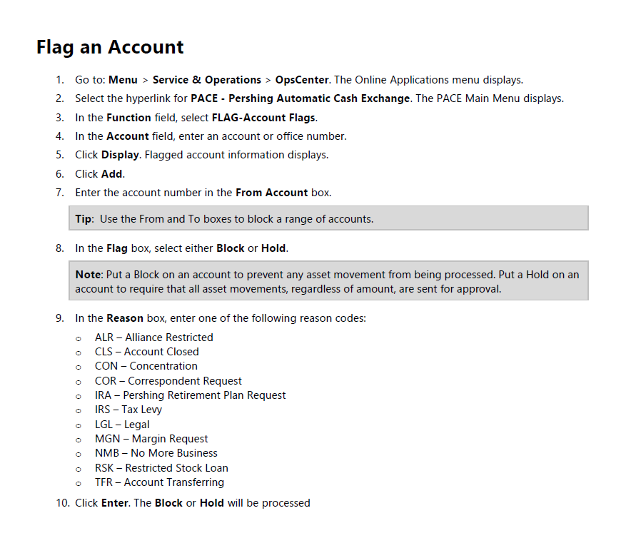

BITCOIN
Tuesday, February 3, 2026
4:56 PM

cryptocurrencies related

GRAYSCALE BITCOIN MINI TR ETF is currently restricted/prohibited as it is cryptocurrencies related. Client transferred in the position from another financial institution.

Considering client is liquidating the entire position on this security. Compliance has no further concerns over this sell order.

BQE and GRA Put Legend Back
Wednesday, February 4, 2026
12:28 PM

Hello Denese,

Allow me to explain. The client intends to transfer out their account to a different firm. In this account, the client holds two positions BQE and GRA.
Both positions were received as legended physical certificates.
The certificates were deposited and legend were removed. Since this client is transferring out, can you please advise whether the client has to re-register BQE and GRA in certificate format and have the legends reapplied? Also, instead of submitting the transfer form, can the client request transfer out using the letter of authorization? I look forward to your response, thank you. Yuan.
<<Hanni account.docx>>

<<hanni account.xlsx>>

Wednesday, February 4, 2026
2:12 PM

1RJ019877 20.53
1RJ016717 0.06
1RJ017129 0.07

Wednesday, February 4, 2026
4:06 PM

Thursday, February 5, 2026
1:03 PM

ADAM SKILLEN Document integrity

Wednesday, February 11, 2026
2:05 PM

Hello Chris,

Per you instructions on the previous request(Request ID:SCW0X00005XT), the registration will remain the same, and we would like to proceed with a physical certificate.

Thanks for your help.

Hi Chris,

The new request has been submitted. Thank you.

Document Integrity Harp Sandu
Thursday, February 12, 2026
10:54 AM

Vincent:
- For the below accounts and affected docs were their changes made after the document had been electronically signed? Can we compare the timing of the change with the latest cert of authenticity that was generated?

Account Number | Affected Document(s) | Issue
P74058648 | Ambassador Non-Discretionary Client Agreement | DocuSign signature on the Ambassador Agreement appears to be copied from other documents.
P74057616 | - Ambassador Non-Discretionary Client Agreement  - Adoption Agreement | DocuSign signatures on both the Ambassador Agreement and Adoption Agreement appear to be copied.
P74057525 | Automated Clearing House (ACH) Form | The ACH form is marked as rejected in the document center, but the DocuSign signature appears to be copied.
P74057962 | New Account Form | DocuSign signature on the New Account Form appears to be copied.
P75011885 | Automated Clearing House (ACH) Form | ACH form is marked as rejected in the document center, but the DocuSign signature appears to be copied.

P74057616 same envelope, same signature number, but sign date is different

P74057962 same envelope ID, same file, but e signature looks different

P75011885 only one 31b86

Canadian dollar check
Friday, February 13, 2026
1:30 PM

Compliance oversight- checks log

Save all the emails in the folder
1 canada check, 2 confirmation to pershing

Date received in branch: first email pdf file, document property- created time
FA name from Next, vancouver time

Time of day sent to pershing: toronto time- Check Approved by date

LPSQ Bear Creek Capital - 1RJ009720
Friday, February 13, 2026
2:48 PM

Security identifiers
- Issuer: TempraMed Technologies Ltd.
- CUSIP: 88024B102
- Exchange/Ticker: CSE: VIVI (Canadian Securities Exchange)
- Sector/Industry: Industrial Services → Logistics & Supply Chain Service Providers
Business description (issuer-provided): Develops temperature-controlled medication storage devices (patented, FDA-registered, space-grade thermal insulation, no power/charging required).

Restricted list: validation failed
Canari: no result

Pershing’s policy regarding physical deposit, electronic delivery, or transfer agent-initiated deposits (example, deposits/withdrawals at custodians [DWACs]) or direct registration system (DRS) of equity securities will now prohibit receipt of securities that are either:
Priced less than 50 cents per share (USD),

Table: rule 144 non-affiliate

However, the DRS statement shows restriction. Although Operations may be able to process the request, there is a risk that Pershing may reject the deposit.
The client contacts the transfer agent to convert and reissue the physical certificate for

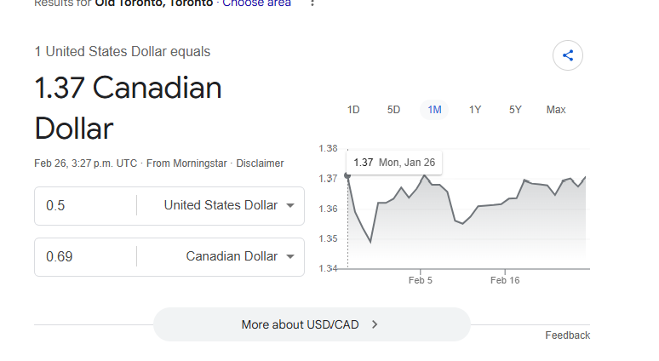
October 15, 2025 – Toronto, ON – The Canadian Securities Exchange (“CSE” or “the Exchange”) today welcomed the listing of TempraMed Technologies Ltd. (“TempraMed” or the “Company”). The Company, based in Israel, recently completed a C$7.4 million private placement qualifying the issuance of approximately 51.7 million common shares. The common shares were listed for trading today on the CSE under the ticker symbol VIVI.

52 Week Range
CA$0.70 - CA$1.40

How did client acquire the shares?
The client acquired the TempraMed shares by subscribing to a private placement of Subscription Receipts of GF Greenfield Ventures Inc. at C$0.75 per receipt. These Subscription Receipts automatically converted into shares and warrants upon satisfaction of escrow conditions, in connection with the reverse takeover by TempraMed Israel Ltd., resulting in the publicly listed TempraMed Technologies Ltd. (VIVI) shares.

Not blue sky compliant and
DRS statement:
DRS restriction (“8880 U.S. Restriction”):
Indicates shares are restricted from U.S. resale (1933 Act unregistered securities).
Typical implications:
No settlement in U.S. market for U.S. persons.
May be freely tradable outside the U.S. if (i) sold on a foreign market (e.g., CSE), (ii) seller & buyer are non-U.S., and (iii) any distribution compliance period (if applicable) has expired, or a legend removal event has occurred per counsel/TA.
The legend on the issuer’s register (reflected by DRS notation) will prevent DTC eligibility and U.S. broker-dealers from settling sales unless the legend is formally cleared.

C$0.75 per Purchased Subscription Receipt for a total Subscription Price of C$__15,000
Current price Now is 0.83

✅ 1. Not registered under the U.S. Securities Act of 1933
Because the shares were issued in a private placement, they are restricted securities and not eligible for free trading in the U.S.

✅ 2. Only four types of transfers are permitted
The holder may only sell or transfer the security in one of the following ways:
- Back to the company
- Outside the United States under Regulation S Rule 904
  - Buyer must be outside the U.S.
  - No U.S. market involvement
  - No U.S. solicitation
- Under Rule 144, if available
  - Requires meeting SEC Rule 144 conditions (holding period, non-affiliate, adequate current information, etc.)
  - Usually requires a legal opinion letter
- Another valid exemption
  - Must provide a legal opinion acceptable to the company to prove the trade is exempt from U.S. registration requirements

✅ 3. Restrictions apply until a legal opinion clears it
For options (3) and (4), the seller must provide the issuer/transfer agent with a lawyer’s opinion confirming that the sale complies with U.S. securities law.

The shares are restricted and cannot be sold or transferred in the U.S.; they can only be sold outside the U.S. (Reg S), or under Rule 144/exemptions with a legal opinion.

We have trade at 0.61 cents know, they want transfer DRS? If not is there're any requriment

Can you advise us of what kind of information is missing?

Hi Harris, when you have a moment, could you please review this draft email regarding Frank Hook’s question in the inbox about Bear Creek Capital – 1RJ009720?

Hello Frank,

Hope you are well.

Pershing does not currently have a price or a transfer agent on file for TempraMed Technologies Ltd. (CUSIP: 88024B102). Without this information, the security cannot be accepted or held at BNY/Pershing.

In addition, the security is not Blue Sky compliant in Canari and does not appear on the restriction report, so we have very limited information regarding its eligibility and regulatory status.

Here are a few additional points:

The DRS statement includes a legend indicating that Pershing may reject the deposit. If the client wishes to proceed, the client must contact the transfer agent to convert and reissue a physical certificate for deposit.

We also noted that the most recent price available is CA$0.78 (approximately USD 0.57). Under Pershing’s policy, physical deposits, electronic deliveries, DWAC/DRS deposits, or any transfer-agent–initiated deposits cannot be accepted if the security is priced below USD 0.50 per share. If a deposit request is submitted and the current share price fluctuates and falls below USD 0.50 at that time, Pershing will reject the position.

Pro trade violation
Monday, February 23, 2026
11:24 AM

<<Pro-client Trade Account Surveillance - Stephen Bishop - 2025-09-29.msg>>

R:\Compliance Oversight\Pro-Client Trades Violation Emails

Monday, February 23, 2026
1:16 PM

Dailies
Feb 26- march 6 prep file
March 9th - 20th Iisa do the dailies, and cover blue sky.

May travel
Monday, February 23, 2026
4:04 PM

Rj net : Egencia hotel
Expedia : Flights ticket400-600
Td aeriplan

Pending task, waiting for money transfer
Tuesday, February 24, 2026
11:23 AM

General inquery - pending paper
Hello, the client is requesting the reissue of a physical certificate with the legends reapplied. They intend to receive the physical certificate in the address on file. The account is sufficient for the fee.
Please proceed with issuing a physical certificate for the security.
1RJ007005

Rjlu books record

9802 already completed

Issue Physical Certificate
Hello, the client is requesting the reissue of a
physical certificate with the legends reapplied.
They intend to receive the physical certificate
in the address on file. The account is sufficient
for the fee.
Please proceed with issuing a physical
certificate for the security.

Tuesday, February 24, 2026
3:52 PM

Continued Education
Wednesday, February 25, 2026
12:26 PM

R:\1 - Compliance\Continuing Education (CE)\Annual Compliance Interview\2025\Responses

Wednesday, February 25, 2026
1:57 PM

Below 50 cents USD have problem
By the time of deposit, pershing might reject

Our client are lookinhg to deposit the security, but we can't find information on pershing security search on Next 360. Do you have concerns

Wednesday, February 25, 2026
3:04 PM

Hi Richard,

Please see below for the current Blue Sky status for the aforementioned securities:

CUSIP | Symbol | Blue Sky (North Carolina)
14042M102 | CPXWF | Yes
00208D408 | AETUF | No

Please let me know if you have other questions.

Pending issue
Thursday, February 26, 2026
9:55 AM

Hondo - ACH Withdrawal, need to reapply block

IBIT
Friday, February 27, 2026
10:18 AM

Feed based: P74, P75
Commission based: 1RJ

If account starts with P35 or is not RJLU, forward to Compliance Help for RJL handling

  - Fee-Based Accounts
    - Non-Discretionary Managed Accounts
      - Adviser may accept unsolicited orders if the trades are suitable for the client
      - Investment recommendations must be unbiased and based on information provided by the client
      - RJLU provides full brokerage services included investment advice, account reviews, and trade execution
    - Discretionary Managed Accounts
      - Portfolio Manager is authorized to exercise his/her discretion to make investment decisions within the framework of the client’s overall investment objectives
  - Commission-based Accounts
    - Adviser may accept unsolicited orders if the trade is suitable for the client
    - Investment recommendations must be unbiased and based on information provided by the client

Please be advised there is a very limited carve out on how this type of security can be purchased:

Current eligibility requirements
Clients are eligible to place unsolicited market orders if the following conditions are met:
  - The account is commission-based, either taxable or IRA. ERISA accounts are not eligible.
  - The account is part of a mail packet with at least $1 million in assets.
  - Asset concentration within the mail packet is under 5%.
  - Trade must be approved by BM.
  - The Account Purpose/Risk Tolerance is Wealth Accumulation/Aggressive.
    - For legacy parameters: Objective/Risk Tolerance must be Speculation/High.

Unless the trade meets the above criteria, the purchase of IBIT is not permitted.

In addition to the fact that the account has to be a 1RJ account and the order must be unsolicited, the following conditions must hold true as well:

  - The client must have a minimum of net household assets of $1m USD.
  - The amount being purchased cannot be more than 5% of the total net household value.
  - Client must have a risk tolerance of Aggressive Growth.
  - Trade must be approved by BM.

Please let me know if you have any additional questions or concerns.

Hi Doug and Stephanie,

Hope you are well.

Please be advised there is a very limited carve out on how this type of security can be purchased:

Current eligibility requirements
Clients are eligible to place unsolicited market orders if the following conditions are met:
  - The account is commission-based, either taxable or IRA. ERISA accounts are not eligible.
  - The account is part of a household with at least $1 million in assets.
  - Asset concentration within the household is under 5%.
  - Trade must be approved by BM.
  - The Account Purpose/Risk Tolerance is Wealth Accumulation/Aggressive.
    - For legacy parameters: Objective/Risk Tolerance must be Speculation/High.

Unless the trade meets the above criteria, the purchase of IBIT is not permitted.

Please let us know if you have any additional questions or concerns.

What does fee based vs Non Fee based have to do with anything

Hope you are well.

The main reason for this restriction is to ensure suitability and to avoid fiduciary conflict of interest.

Fee-based accounts operate under a fiduciary standard, requiring advisers to provide duty of care and guidance with prudent investment choices to clients. Crypto and crypto-related ETPs, which are seen as speculative and highly volatile, may not meet these strict standards.

Conversely, commission-based accounts operate under a "suitability" or best interest standard, which is less rigorous and so purchasing the aforementioned securities for clients on an unsolicited basis in these types of accounts is seen as less problematic.

Please let me know if you have any additional questions or concerns.

So if the client wants to do more purchases do we need to open a commission account. Will that fix this situation??

Hi Doug,
From a suitability standpoint, commission-based accounts are generally subject to a less stringent standard than fee-based accounts.
However, opening a commission account on its own would not fully resolve the situation. All previously outlined requirements and conditions would still need to be met before any additional purchases of crypto or crypto-related ETPs can move forward.
Current eligibility requirements
Clients are eligible to place unsolicited market orders if the following conditions are met:
- The account is commission-based, either taxable or IRA. ERISA accounts are not eligible.
- The account is part of a household with at least $1 million in assets.
- Asset concentration within the household is under 5%.
- Trade must be approved by BM.
- The Account Purpose/Risk Tolerance is Wealth Accumulation/Aggressive.
  - For legacy parameters: Objective/Risk Tolerance must be Speculation/High.

Unless the trade meets the above criteria, the purchase of IBIT is not permitted.

Hi Harris, please kindly review the draft email:

Hi Doug,

From a suitability and conflict-of-interest standpoint, commission-based accounts are subject to a less stringent standard than fee-based accounts.

However, opening a commission account on its own would not fully resolve the situation. All previously outlined requirements and conditions would still need to be met before any additional purchases of crypto or crypto-related ETPs can move forward.

Current eligibility requirements:
Clients are eligible to place unsolicited market orders if the following conditions are met:
· The account is commission-based, either taxable or IRA. ERISA accounts are not eligible.
· The account is part of a household with at least $1 million in assets.
· Asset concentration within the household is under 5%.
· Trade must be approved by BM.
· The Account Purpose/Risk Tolerance is Wealth Accumulation/Aggressive.
o For legacy parameters: Objective/Risk Tolerance must be Speculation/High.

Unless the trade meets the above criteria, the purchase of IBIT is not permitted.

Pershing Contacts
Friday, February 27, 2026
1:41 PM

For service related or general inquires
"Wealth Solutions BD Service Team" <bdservice@pershing.com>
"White, Sandra" <sandy.stokes@bny.com>
"Sullivent, Gregory" <gregory.sullivent@bny.com>

Physical Certificates or Custody related:
"Stewart, Denese" <denese.stewart@bny.com>
"Khan, Jay" <jay.khan@bny.com>
"Cintron, Marc" <marc.cintron@bny.com>

<<New Pershing Contact 2023 - HANDOUT.pptx>>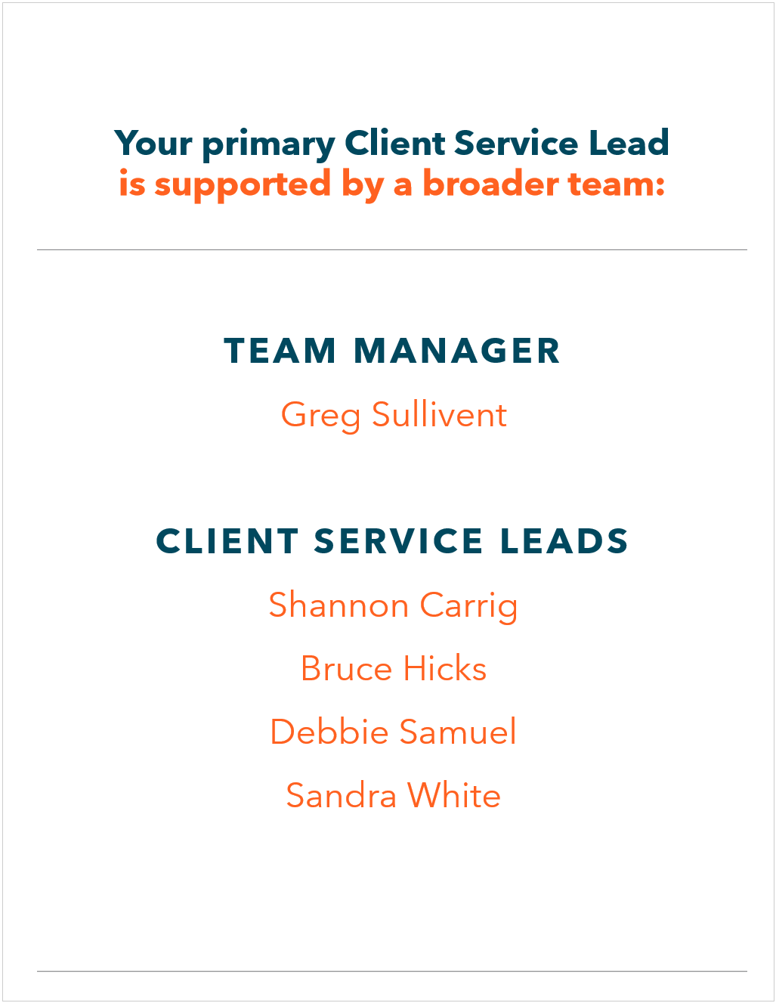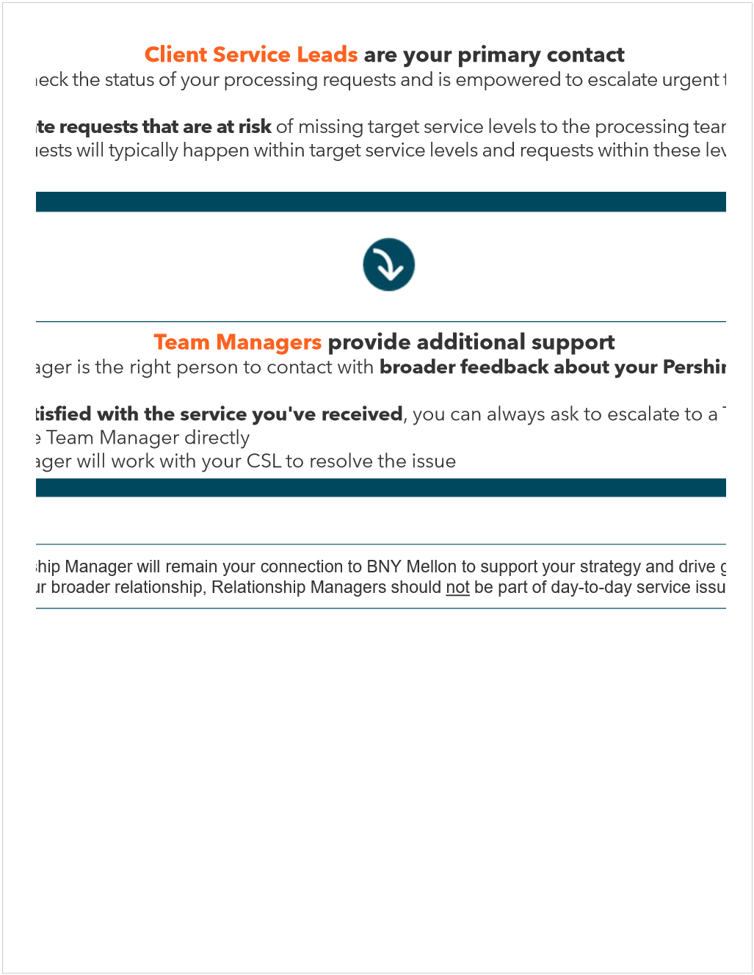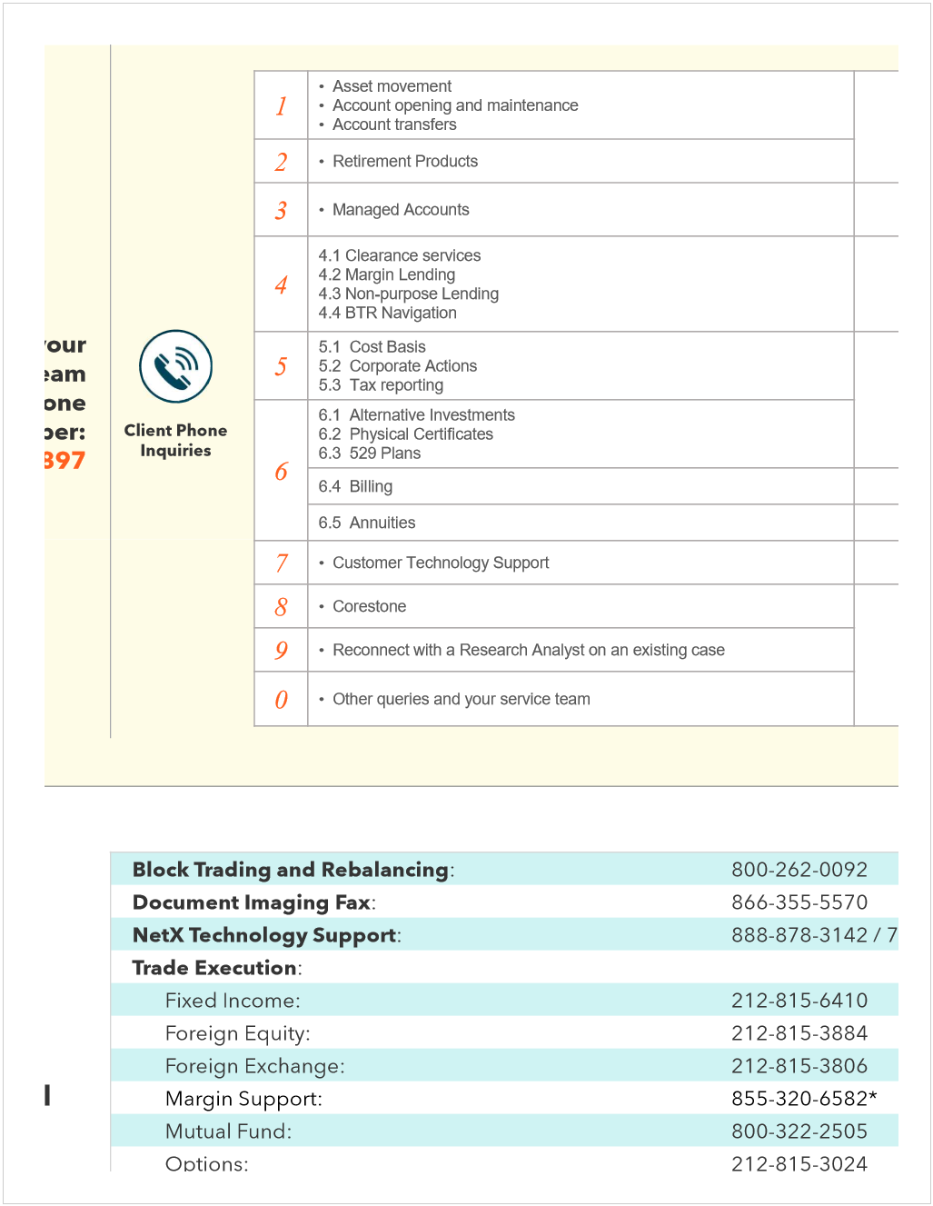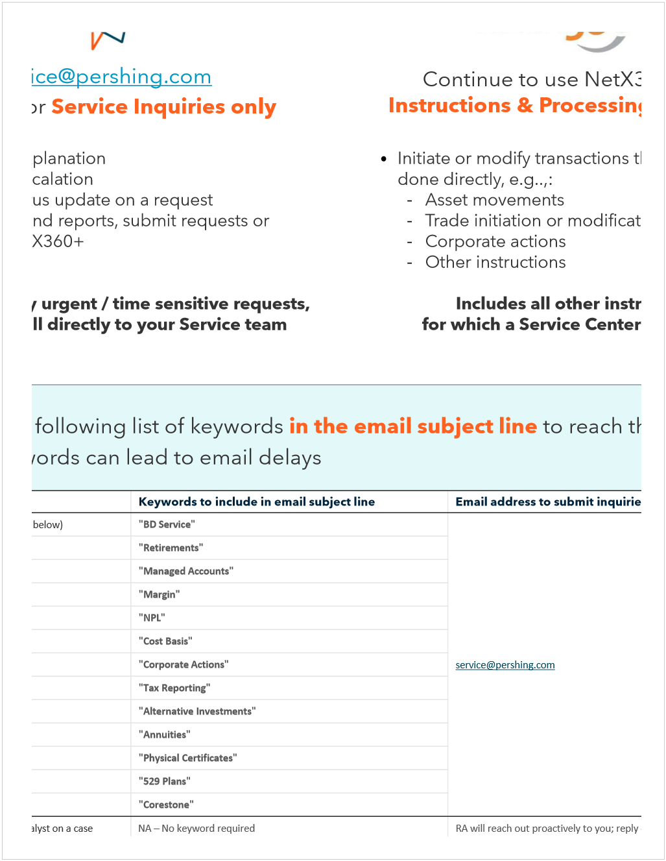

Monday, March 2, 2026
9:33 AM

Minera Alamos Inc 60283L808

Today's 3 reports on NetX360 show no updates:
- Commission Analysis Daily Detail Report
- Short Interest Period
- Acting-in-Concert Groupings for Large Options Positions

Large Options Positions has an update. I saved file in R:\Compliance Oversight\Large Options Positions Transmitted to OCC\2026
Please kindly review and sign it.

Monday, March 2, 2026
2:26 PM

After several rounds of communication with Pershing, right now Pershing are not able to accept this security. Since security is not going to accepted by pershing, Rjlu compalince are not able to complete the due diligence review.

Hi Harris, could you have a look of the draft email below?

Hello Carol,

Hope you are well.

Thank you for your patience while we followed up with Pershing regarding this security.

After several rounds of communication, Pershing has confirmed that they are currently unable to accept this security for deposit. As a result, RJLU Compliance is unable to move forward with the due diligence review at this time.

If anything changes on Pershing’s side, we would be happy to review the request again.

restricted Cusip
Thursday, March 5, 2026
10:23 AM

Currently, KANP, CUSIP: 48282H308 is restricted/prohibited, the reason for restriction is that the security is categorized as Pink - Limited Information. The FA was notified about this restricted holding yesterday during our weekly look back program (please see attached), and the FA is following the instruction given in the notification. This order will liquidate client’s entire position in this security. Hence, compliance has no issues to allow this sell order. Thank you!

Blue Sky Violation
Thursday, March 5, 2026
10:24 AM

A few things needed from below escalation:

- As the action has been confirmed by FA and BM, update the original record in the corresponding daily trade review, make sure the notes reflect the action and date of the action.
- Save the correspondence in R:\Compliance Oversight\Blue Sky Violations Email, if there no advisor related folders, please create a new one.
- Update the “Blue Sky Violation Log (starting September 19, 2022)” located in R:\Compliance Oversight\Blue Sky Violations Email

Meeting Report
Wednesday, March 11, 2026
2:09 PM

The FA asked Steven, “Can you please get these items approved? It’s for a much larger relationship with this client.”
Steven received approval this morning from HAS Bank to contract with them and is now waiting for the documents to be sent to him. When he tried to open the account in Client Onboarding, he didn’t see an option for a Health Savings Account (HSA).
He also sent a message to Pershing asking if someone could reach out and help him understand how to open these accounts, because there are two pending items: one for John Woodfield and another for Bob McDonald. Both of these are legal HSA accounts.
Once he understand the correct process for opening them,He’ll gather more information. He asked you to learn the proper steps and likely reach out to RJA to obtain their policy, then adapt it for our own internal procedures.

During the discussion, Steven mentioned that they are currently working on setting up Health Savings Accounts (HSA) for a client relationship that is expected to be significantly larger.
He confirmed that approval has already been obtained from HSA Bank to contract with them, and he is currently waiting for the required documents to be sent over.
However, when attempting to proceed with the client onboarding process, he noticed that there is no option available to open a Health Savings Account within the onboarding system. As a result, he has reached out to Pershing requesting clarification on how these accounts should be opened through the system.
one for John Woodfield and another for Bob McDonald. Both of these are legal HSA accounts.
Once he understand the correct process for opening them, He’ll gather more information. He asked you to learn the proper steps and likely reach out to RJA to obtain their policy, then adapt it for our own internal procedures.

Thursday, March 12, 2026
2:24 PM

  - Process
  - Goes to branch manager

Friday, March 13, 2026
3:56 PM

On 7/18/2024, Steven Marcus asked to PACE the block,

CIP was rerun due to a trigger event as Robert was removed from the entity
Not get all an address for Jason as we requested.

As long as goes to the same place, I think we're fine

Same recipient? Who the recepient
Withdraw can be remove

Hi KM,

Compliance has no concern as the recipient is the same as the last time's transaction

Compliance has no concerns at this time, as the recipient is the same as in the December 2025 transaction. Also we already get back to operations.

Hi KM,

Compliance has no concern as the recipient is the same as the last time's transaction.

Please place the PACE block back after temporarily transaction.

the main person involved with the partnership rob weiner left the partnership and needed new forms indicating what the new partnership structure is

CIP was rerun due to a trigger event as Robert was removed from the entity and needed new forms indicating what the new partnership structure is. Please also check if confirmation of an address for Jason as AML requested.

CIP was rerun due to a trigger event as Robert S. Weiner was removed from the entity. Equifax wasn’t able to verify Jason’s address, nothing with his physical residential address. Please check if file that confirms his address already provided as request from AML before.

Tuesday, March 17, 2026
3:16 PM

Pace block inntyiated by you, could you privde your response regardingre the email below

Still attach email that

LPSQ - Yangarra
Wednesday, March 18, 2026
2:00 PM

CUSIP: 98474P501
Total amount: 100,333 common shares
How did client acquire the shares?
Client acquired the shares as part of the director compensation. Client exercised options and then sold a portion of the shares to cover the exercise price.
Read question 10: check physical certificate
Restrictive legend - board or affiliation with the company
Reg S 904 restrictive legend

The security is not restricted/prohibited by the security review group from RJF.
Blue sky in client residence MT

Breakdown:

Business description: no issue
Yangarra Resources Ltd. engages in the exploration, development, and production of oil and natural gas.

Past Email:

Hello Darrin,

Please find attached the LPSQ and related supporting document for your review.

Client Frederick Morton, P74058028, requested to deposit 57,000 shares of Yangarra Resources Ltd, which is currently trading at $1.00 CAD.

Client is currently an insider and a board director of the issuer. Client acquired the shares as part of the director compensation. The shares are currently bearing the Reg S 904 restrictive legend. Compliance has no further concerns regarding this deposit.

The security is not restricted/prohibited by the security review group from RJF.

Kindly review and provide us with a signed copy of the LPSQ, if approved on your end.

Good morning Milene,

Please find attached the LPSQ and related supporting document for your review.

Client Frederick Morton, P74058028, requested to deposit 28,111 shares of Yangarra Resources Ltd, which is currently trading at $0.76 USD.

Client is currently an insider and a board director of the issuer. From the Sedi report attached, we can confirm that the client acquired the shares from exercise of rights. We also got confirmation from the issuer that the shares issued are unrestricted and fully vested. The deposit has been reviewed by the RJLU CCO, Ash Chester, and compliance has no further concerns regarding this deposit.

Kindly review and provide us with a signed copy of the LPSQ, if approved on your end.

Kind Regards,
Vincent

Thank you for the introduction, Zafar. I see from the information provided that that there are three different tranches of shares: 7,000 shares issued on January 2, 2024, 40,000 shares issued on May 5, 2025, and 10,000 shares with no documentation indicating the issue date. I note that the physical stock certificates are all dated August 19, 2025. In order to assess the available exemptions to facilitate a legend removal and/or share transfer, please provide the original issue date of the tranche of 10,000 shares. In addition, I need to know whether Mr. Morton is an affiliate of Yangarra. Specifically, I need to know whether he is a director, officer or owner of 10% or more of any Yangarra class of voting capital stock. Also, it would be helpful to understand if Mr. Morton is intending to sell these shares, or if he is only trying to remove the legend to facilitate depositing the shares in a brokerage account.

Under U.S. law, Rule 144 promulgated under the Securities Act of 1933 only permits legend removal that is not in connection with a sale or transfer of the subject securities if the shares have been owned for at least 12 months and the holder is not an affiliate. In this regard, the tranche of 7,000 shares issued on January 2, 2024 have been held for at least 12 months and we could issue an opinion to remove the legend if Mr. Mortan is not an affiliate of Yangarra. However, the tranche of 40,000 shares issued on May 5, 2025 have not been held for at least 12 months and therefore would not be eligible for legend removal under Rule 144.

Section 4(a)(7) of the Securities Act of 1933 provides for a statutory exemption for the sale of shares that have been held for at least 90 days, subject to certain public information about the company being available and only if the purchasers qualify as accredited investors as defined in Rule 501 of the Securities Act of 1933. As a public reporting company in Canada, Yangarra satisfies the public information requirements of Section 4(a)(7), so we could issue an opinion to remove the legend with respect to the 40,000 shares in connection with the sale of the shares to an accredited investor. Such opinion would only apply to a specific sale to a specific purchaser whose accredited status was confirmed, and the purchaser would receive the shares subject to the same restrictive legend.

Treatment of the tranche of 10,000 shares will depend on the original issue date and whether the Rule 144 or Section 4(a)(7) exemptions are available.

Response

Thank you for this additional information. Unfortunately, because he sits on the board, he is an affiliate of the company and the legend cannot be removed for as long as he remaina an affiliate and for a period of 90 days thereafter.

Although legend removal is not available to affiliates, he would still be able to sell the shares immediately to accredited investors in the US (in reliance on the 4(a)(7) exemption) or in offshore transactions that occur outside of the United States where the purchasers are neither US citizens nor US residents (in reliance on the Regulation S exemption). After any shares have been held for at least a year from the original issue date, he would be able to sell shares in reliance on the rule 144 exemption, but could not sell shares in an amount that exceeded one percent of the total outstanding shares of that class in a 90 day period and only if there was current public information about the company available (principally, its most recent annual and quarterly financial statements). The legal opinion for the legend removal under rule 144 in this circumstance would be specific to the transaction and woukd have to confirm the conditions of the exemption were met at the time of such transaction.

Wednesday, March 25, 2026
11:18 AM

Thank you for providing these information. We will provide to pershing to confirm incoming documents, and we're preparing the brokers letter and branch manger sign it will mail it to Pershing

Legend removal
Wednesday, March 25, 2026
12:58 PM

<<Legend Removal Expediting Request.msg>>

Hello Jay,

Hope this email finds you well.

We are hoping to expedite a legend-removal request for account 1RJ021360 – HONDO PRIVATE EQUITY LLC, which has already been submitted to your Canadian agent. We are wondering if there is any way to accelerate the process with the transfer agent and your Canadian third party. If there are any associated fees for expediting the request, please let me know — we are prepared to absorb the cost.

The client has also provided a direct contact at the transfer agent who can assist with processing this request: Colleen Nielsen – Colleen.Nielsen@computershare.com

Kind Regards,
Vincent

<<904 BL - HONDO PRIVATE EQUITY LLC - Ucore Rare Metals 625,000 shares - 1RJ021360 - Jan 15, 2026.pdf>>

Desktop Procedures
Wednesday, March 25, 2026
2:59 PM

R:\1 - Compliance\Policies, Procedures and WSPs Project\Desktop Procedures\DRAFT

Friday, March 27, 2026
1:10 PM

Qtrade TFSA(accumulated) RRSP
FRIST HOME SAVING ACCOUNT FA

Wealth simple tax account
- Bank T5 how many forms
- Avanti: T4 salary PERSONAL- DOCUMENT-EMPLOYEE DOCUMENT-T4, Tax slip form
- Avanti: T2200 business cost
- Tuition, total amount
- Rental Receipt from 2025.01-2025.12
- Manual Life RRSP form, group retirement plan, download
Due:4.30

T1 federal tuition/provincial tuition

Friday, March 27, 2026
1:27 PM

Physical certificate questionnaire

Please fill out
Physicla certificate back and forth
How client acquire that

Hello Ruby,

If the client would like to proceed to deposit the physical ce


Physical Security Certificate Questionnaire

From <https://raymondjamescan.sharepoint.com/sites/rjnet-ps-rjlu/RJLU%20Compliance%20Forms/Physical%20Security%20Certificate%20Questionnaire.pdf?web=1>

rtificate, the following steps must be completed to satisfy the compliance due diligence review process:

- Scanned copies (front and back) of physical stock certificates.
- A completed Physical Security Certificate Questionnaire.
- Electronic signature summary (if applicable).
- Supporting documents (e.g., subscription agreements) showing how the shares were acquired.

Kindly let me know if you have any questions.

Monday, March 30, 2026
2:22 PM

SEDI-ACCESS PUBLIC FILINGS-view insider information

Unsolicited: restricted, cc BM fiduciary responsibility, if fee based.
If commission based, client can buy whatever they want

We need pdf to show all details, log approve time

Please charge the Rush Request Fee ($400) to 1RJ021360.

Please kindly confirm that Pershing can charge the Rush Request Fee ($400) to client's account 1RJ021360

Please charge the Rush Request Fee ($400) to 1RJ021360.

Please kindly confirm that Pershing can apply the Rush Request Fee ($400) to the client’s account 1RJ021360.

Please charge the Rush Request Fee ($400) to 1RJ021360.

Please charge the Rush Request Fee ($400) to 1RJ021360.

charge the Rush Request Fee ($400) to the client’s account 1RJ021360.

Blue Sky Violation
Tuesday, March 31, 2026
11:45 AM

Recession letter:
On netx
Security is the security symbol
Total cost is checking "money" part

Wednesday, April 1, 2026
1:53 PM

Mitch’s LPSQ has been approved, and we are waiting for the client to provide the required documents.
Also, he had a Blue Sky violation yesterday.

Legend removal for Ucore (3.6 million shares) has been sent to Pershing on a rush basis.

Inbox item: 1RJ 008383 / Mike Kmetz – Deposit of HMMC:CA (Hemlo Mining Corp.), 23,333 restricted shares. I will review this tomorrow or early next week.

There is currently no system that automatically updates the RTQ and reflects the most recent risk tolerance information. If an FA completes a new RTQ without notifying us, we may continue relying on outdated data when assessing offside status. Even when updates are provided, they must be entered manually, which is time consuming and still carries a risk of inaccuracies.

We say this in dococument center but we' don’t see It in transaction, can you let us know what happens

Harris, we have some one asking discloure? Who shold we dirrect to?

There is an email in the inbox subject: Confirmation Needed on Cross-Border Disclaimer. I disccussed with Vincent but not sure who should we direct to? Please let me know

Wednesday, April 1, 2026
5:07 PM

Email to pershing

Midyear review

Thursday, April 2, 2026
11:58 AM

Could you help bred

Blue Sky Violation new template
Monday, April 6, 2026
3:05 PM

<<RE_ Rescission Letters Pending Approval - P74038210.msg>>

Monday, April 6, 2026
4:18 PM

Wednesday, April 8, 2026
12:43 PM

TFSA
QTRADE Open TFSA ACCOUNT canadian account
High insterest ETF savings account
Wealthsimple checking account

Imprpoper access netx user

Wednesday, April 8, 2026
2:12 PM

CCL Industries Inc. (CUSIP :124900309) is currently Blue Sky in Connecticut.

Please let me know if you have other questions.

John Hancock Freedom 529 (CUSIP :280911694) is currently not Blue Sky in
Washington State.

Hi Alex,

From compliance perspective, we can confirm which securities are eligible for solicited trade in

We are not able to provide you lis t of procucts. We we're happpy to check list if you plan for

We are not able to provide a list of products. However, we are happy to check any 529 plans you provide with the correspongsing CUSIPs

- Look both accounts and check position, do we get restricted back
- Do we have physical cerficcker with legend

From a compliance perspective, we are unable to provide a list of products. However, we would be happy to check eligibility for any additional 529 plans you provide, along with the corresponding CUSIPs.

We have additional layeThis is not blue sky compliant in the state
States level benift, different requiremenr for state

Each state has own requirement, state regulated plan

Reasign in that state and invest only approved by stae

Blue sky is different level of requiremetn, subject to action solicited secuirty to the residence of states.
Client wants to buy it

1.restrion we talk about is blue sky requiremirmenrt. Can't be solicietd to the the client.

1RJ 008383 / Mike Kmetz: Deposit of HMMC:CA / Hemlo Mining Corp. (QTY 23,333 restricted)
Wednesday, April 8, 2026
4:08 PM

42366G104

From <https://my.apps.factset.com/workstation/navigator/company-security/snapshot/HMMC-CA>

Sedar check
Hemlo Mining Corp. / Hemlo Mining Corp. (000027219)

supporting documents

Friday, April 10, 2026
11:58 AM

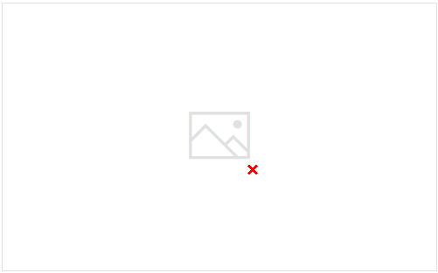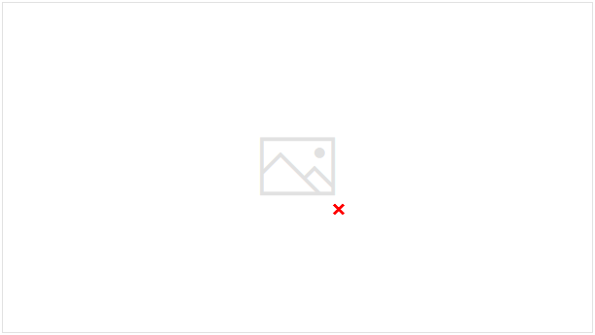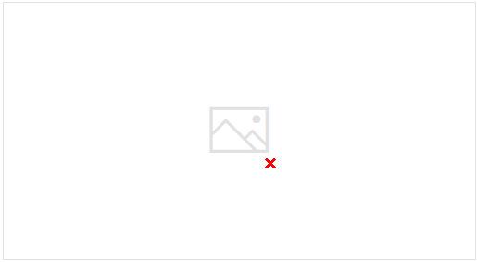

Monday, April 13, 2026
11:56 AM

The applicability of Blue Sky requirements pertains to the solicitation of purchase orders for U.S. residents, and are not specific to the product.

Steven Van Ert – 1RJ013706. pace block remove

Monday, April 13, 2026
4:12 PM



Upon reassement, we have identifyed

